

Electricity North West’s

**Plugged in Public Panel**

Full Panel Report

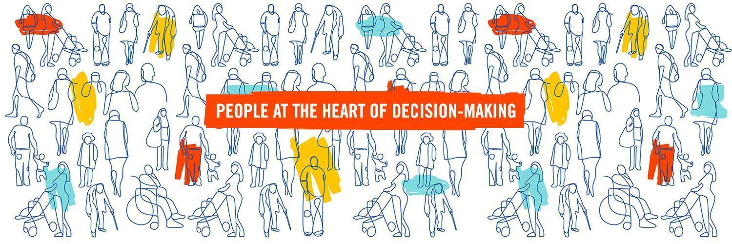

**AUTHORS:** Dominic Ward, Senior Project Officer, Involve and Kaela Scott, Head of Democratic Innovation, Involve

**DATE:** 02/02/2021

**Contents**

Executive Summary 4

1. Purpose of the Electricity North West Plugged In Public Panel 6

2. Engagement Methodology 7

3. Participants in the Electricity North West Plugged In Public Panel 9

Recruitment methodology 9

Members 10

4. Overview of the 6 Panel meetings 14

5. Electricity North West’s Priorities 15

Chapter overview 15

Improvement Priorities 16

Ranking the priorities in Panel 1 16

Ranking the priorities in Panel 6 17

The priority which significantly increased in importance to members 19

Priorities which decreased in importance to members 21

6. Investment and Affordability 26

Chapter Overview 26

Priorities for Investment 27

Draft Business Plan Package 28

Affordability of Electricity North West’s Draft Business Plan Package 29

Personal acceptability to members 29

Fairness of proposed bill increase 30

7. Network priorities 32

Chapter Overview 32

Network Investment 32

Investment to improve network performance 33

Delivering a reliable network 35

Building a resilient network 36

Keeping our communities safe 36

Balancing investment and risk 37

Who should benefit most? 38

8. Environmental Priorities 41

Chapter overview 41

Environmental improvements 41

Investing in environmental priorities 42

Initial Member priorities 42

Leading the North West to Net Zero 44

Pace of change towards Net Zero 46

Decarbonising options 47

Allocation of resources across decarbonising options 48

Addressing Electricity North West’s direct environmental impact 49

Non-decarbonising environmental actions 49

Paying for improvements 51

Making sure no-one is left behind by the energy transition 52

9. Customer Service 54

Chapter overview 54

Customer Service Priorities 55

Should Electricity North West invest more in customer service 55

The 5 steps of the customer fault experience 56

Improving customer service during a power cut 59

Priority Service Register 60

PSR recruitment targets 60

Fuel poverty 64

Protecting customers in vulnerable circumstances and making sure no-one is left behind 67

10. Conclusions 70

Key points of agreement 70

Key points of disagreement 70

Key changes 71

Most important areas for investment 71

11. Process Evaluation 73

About the days 73

About the meetings 73

# Executive Summary

Electricity North West’s Plugged In Public Panel was one of a number of key strategic engagement activities conducted by Electricity North West to enable customers and stakeholders to inform the development of the company’s Business Plan for 2023-2028. This Panel helped Electricity North West obtain an in-depth understanding of customers’ preferences and an understanding of to what extent customers being educated about Electricity North West, and repeatedly engaged in this, influences their decision-making.

### Purpose of the Plugged in Public Panel

The Panel was brought together to address the overarching question:

* **What is the right level of investments that Electricity North West should make in their identified areas for improvement?**

The deliberative engagement method chosen for this Panel consisted of three key stages:

1. Learning
2. Discussion
3. Deliberation.

This allowed members to learn from Electricity North West about issues relevant to the question they were addressing; have time to embed this understanding and ask further questions; discuss them in small breakout groups; and reach conclusions both individually and as part of groups having weighed up the various trade-offs identified. This has provided Electricity North West with rich insight into the values and priorities of panel members on key issues relating to future investments in improvement. This report pulls together the work done by members throughout all the Panel meetings. There are full details of the outputs of each of the six Panels in the separate output reports.

### Panel Members

The Panel was comprised of 40 members who were recruited as a stratified random selection of customers which matched the demographic characteristics of the geographical area (as closely as possible within a group of this size). 35 members completed the sixth panel meeting, with some dropping out due to personal circumstances and/or deciding the process wasn’t for them. The feedback on the process given by those members who completed the process was overwhelmingly positive.

### Structure of the Panel Meetings

The Panel met using Zoom six times between July and November 2020. During the first meeting they learned about the role of Electricity North West in the network, the company’s three clusters of priorities for investment which they wanted to explore: network, environment and customer. Members built on this in the second Panel where they explored key questions of affordability and fairness of these different priorities. Panels 3, 4 and 5 looked at the three clusters in turn. Within these, Panels members considered questions of balancing risk and investment, which customers should benefit most from investments, who should receive particular support and also how to plan for the future energy transition as electricity usage increases.

During the sixth and final Panel meeting, Electricity North West presented their Draft Business Plan Package to members, informed by outputs from the previous Panels. They explored whether the proposals in this package were acceptable to members after they had learned in detail about them and helped refine them in previous sessions. Members also explored questions of bill impact sensitivity and how fair this package was for customers who might struggle to pay for it. Finally, members discussed how Electricity North West should continue to engage with customers in the future and decided they would like to see the Panel reconvened in 2021.

### Findings from the Panel

As part of reviewing the Draft Business Plan Package in Panel 6, members considered seven propositions Electricity North West had developed (building on the original ten priorities that were presented to members). Members were asked to allocate an imaginary £10 for investment across those seven propositions to demonstrate which they felt were most and least important. Reinforcing the findings of their earlier ranking of priorities, Delivering a reliable network and Building a resilient network were ranked as the top two most important priorities. Supporting customers in vulnerable circumstances started off as the fourth most important priority, but dropped to being ranked seventh by the end of Panel 6. As members learned more throughout the Panels about what Electricity North West does and how reliant these customers are on electricity, the view developed that the priority for the company should be to make sure their basic needs are met by Delivering a reliable network and Building a resilient network.

Members ranked Keeping bills as low as possible as one of the lowest priorities after Panel 1 and it became even less of a priority after Panel 6 as members had learned about the benefits which could come from the investment options they were discussing.

Overall members were enthusiastic about the benefits of proposed investments and encouraged Electricity North West to be proactive about investing in a number of areas including network reliability, leading the North West to net zero and supporting customers in fuel poverty. When presented with the Draft Business Plan Package at Panel 6, the majority of members found it personally acceptable and thought it was fair to go ahead with a £9.80 bill increase in order to fund the investments outlined in that package.

# Purpose of the Electricity North West Plugged In Public Panel

The Electricity North West Plugged In Public Panel was one of a number of key strategic engagement activities conducted by Electricity North West to enable customers and stakeholders to inform the development of the company’s Business Plan for 2023-2028. This Panel helped Electricity North West obtain an in-depth understanding of customers’ preferences and an understanding of to what extent customers being educated about Electricity North West and repeatedly engaged in this influences their decision-making.

The overall approach to engagement during this time was to ensure that research was undertaken cumulatively, with each phase building upon knowledge gained in previous phases. Thus, key findings from other Business Plan engagement mechanisms were utilised to identify content and objectives for the Public Panel, such as the long list of priorities for investment presented to the Panel at the beginning.

The Panel was brought together to fundamentally address the question:

* **What is the right level of investments that Electricity North West should make in their identified areas for improvement?**

The objective was to better understand customers’ views on the different areas which Electricity North West could invest to improve in, understand which were the priorities and why, and identify if/how members’ views changed through taking part in the process.

In choosing to convene the Electricity North West Plugged In Public Panel as a ‘mini-public’ the focus was on ensuring that the company engaged, in depth, with a wide variety of customers, including specifically those who did not generally interact with the company. By actively recruiting people from across the region who were not already engaged with the electricity network, or necessarily even interested in it, the members can be argued as representing a true cross-section of Electricity North West’s customer base.

This was seen as particularly important for aspects of the company’s planning where there are no simple ‘right’ decisions, but instead decisions involve making a trade-off between different priorities. Decisions like these are a particularly appropriate focus for deliberative work with representative mini-publics as they benefit from participants being given time, access to balanced and in-depth information about the issues, and the opportunity to discuss their opinions with other customers before drawing conclusions.

# Engagement Methodology

The Electricity North West Plugged In Public Panel was convened using an online, long-form deliberative methodology, involving a representative sample of customers from Electricity North West’s network area, to consider key aspects of the company’s developing Business Plan for the next price control period.

Given this was a new approach for Electricity North West, Involve (the UK’s leading specialists in deliberative engagement) were contracted to design and deliver the process. This was led by Kaela Scott, Head of Democratic Innovation at Involve and Dominic Ward, Senior Project Officer at Involve. They were supported in the delivery of the Panel meetings by a team of 5 facilitators (from Involve’s core team and associate pool) experienced in developing dialogue among diverse groups and encouraging effective deliberation.

The Covid-19 pandemic required that this Panel was designed and delivered wholly online. This meant that meetings of the Panel were run on the video conferencing platform Zoom to allow members to hear presentations from Electricity North West and, in small breakout rooms, have facilitated discussions on their views on what Electricity North West presented and the questions being asked.

Process Design

The principles that underpinned the process design were that deliberative methods offer a distinctive approach to public engagement, which differ from other forms of consultation, because they are fundamentally about giving participants time to learn about and discuss issues in depth before coming to a considered view. As such they can:

* give decision-makers a detailed understanding of informed public opinion on complex issues and/or value-laden and controversial questions; and
* open up the space for revealing consensus, wherein trade-offs have to be made, and a solution that respects the constraints of the policy and practical environment can be found.

The defining characteristic of a deliberative engagement process is that it brings together a group of people, selected to be broadly representative of the demographics of the population (i.e. a mini-public), to deliberate on a significant community or policy issue. This will, by definition, involve three phases:

* **A dedicated learning phase:** A central feature of this approach is the learning component wherein participants are able to develop an understanding of the issue based on unbiased information and/or the clear presentation of arguments from different perspectives. Throughout this phase information can be presented in a variety of ways including presentations from experts, written information and through facilitated discussions.

In this case the learning phase was spread across the 6 Panels, with a weighting towards Panel 1 where members spent the most time learning. At each stage more detailed information was presented for discussion and question. This was to enable members to build up an understanding of the role Electricity North West plays in the supply of electricity, and the areas the company is looking to improve in. Then they took a more detailed look at each of the three clusters in turn - Network, Environment and Customer - considering which areas within them were priorities for improvement.

* **Discussion focused on developing dialogue:**  To enable this, participants tend to work for most of the time in small groups, supported by highly skilled facilitators to engage in dialogue about the topic. This allows time for people to develop and test opinions on issues that are new to them (and on which they do not have a pre-existing opinion), explore their pre-existing opinions in light of what they have heard and encourages a wider understanding of the opinions of others.

The importance of subject experts being available to respond to participants’ questions during this phase cannot be understated and was key to the success of the way this phase of the deliberative process was delivered during the Plugged In Panel meetings.

* **The deliberation phase:** This stage of a deliberative engagement event involves participants coming to some conclusions based on what they have learnt, through a process of public reasoning. While consensus based decision-making processes are the ideal, at this stage voting systems will often be used, as was the case in these meetings to ensure clear outputs are attained at each stage.

This Panel met six times between July and November 2020. Each meeting consisted of a 2 hour morning session and another 2 hour afternoon session, plus a 90 minute lunch break in between. The Panel was designed in this way to allow members sufficient time to learn about, discuss and deliberate on the topics covered, whilst also not placing an undue burden on them of lengthy sessions on Zoom which could prove tiring, particularly for members who were not already familiar with video conferencing platforms.

Central to the success of a deliberative process like this are the variety of exercises and techniques used throughout the online sessions. In this case the process was specifically designed to support all participants to use Zoom and other platforms to engage with complex information and feel able to put their opinion forward on their own terms. Therefore each of the meetings were designed to include a range of ways for members to participate including:

* facilitated breakout discussions;
* collaborative question and idea generation sessions using Jamboard;
* plenary discussions;
* group ranking/negotiation activities in breakout rooms;
* time for individual reflection and note taking;
* opportunities to question the speakers (in breakout rooms and in plenary);
* live interactive polling to instantly gauge the sentiment within the room on key discussion points;
* online surveys after each Panel producing quantitative and qualitative data.

This variety within the process design is important to ensure that all participants are able to contribute in ways that suit them best – verbally during breakout discussions, through written inputs on Jamboard and in post-event surveys, and through time for reflection.

Each of the meetings of the Electricity North West Plugged In Public Panel was designed to adhere to these principles and this led to high levels of engagement from participants, sustained attendance and the production of clear outputs useful to decision makers, as presented in this report.

# Participants in the Electricity North West Plugged In Public Panel

The 40 members of the Electricity North West Plugged In Public Panel were selected to be a representative sample of the overall population of the region i.e. a mini-public. As far as possible the selection of members was undertaken to mirror the demographics of the area, as recorded in the most recent census.

## Recruitment methodology

The rationale behind the Panel approach was to engage a broad cross section of domestic customers from across the region, including those who have had no reason to engage with Electricity North West previously and who may have given little thought to how their electricity network operates. Membership of the Panel was therefore determined through a process of stratified random selection to (as closely as possible within a group of this size) match the demographic characteristics of the geographical area.

Recruitment of participants was undertaken by the Sortition Foundation - a not-for-profit social enterprise dedicated to promoting fair, transparent, inclusive and effective deliberative processes by ensuring accurate representative and random sampling during recruitment.The method they used was based on the idea that, in principle, every resident in the area should have an equal probability of receiving an invitation to take part.

6000 invitations to participate were sent to households within the network area, randomly selected from the Royal Mail Postcode Address File (PAF) - the most complete and up-to-date address database in the UK. The invitations were issued in a specially designed, attractive and informative envelope (with Electricity North West branding) to draw attention to the contents, and included a FAQ sheet, background information relating to Electricity North West and an individual registration code to use to express their interest in joining the Panel. The invitation letter also included the offer of a £60 cash thankyou gift per Panel meeting (a total of £360) to encourage those who might not otherwise be interested in the initiative and help ensure a diverse range of people were motivated to apply.

Historically this method of recruitment tends to attract more expressions of interest from people from professional backgrounds and with higher levels of education. To help address this skewing the Index of Multiple Deprivation[1] was used to identify postcode areas with the highest levels of deprivation and proportionately more addresses were selected in these areas. This meant in practice that 80% of the addresses selected were from the entire Postcode Address File (including areas of deprivation) and the remaining 20% from postcodes with an Index of Multiple Deprivation decile rating of 1-3 (the most deprived areas). By delivering proportionally more invitations to the most deprived areas we aimed to reduce the effects of this skewing.

Potential participants were given two easy ways to register their interest: online or over the phone. Upon registering their interest socio-economic and demographic data was gathered to enable stratification and relevant exclusions (e.g. people who worked for Electricity North West). 164 members of the public applied to be part of the Panel, a response rate of just under 3%.

From the pool of interested respondents a second, stratified random selection was performed, matching the latest UK census data on six dimensions: age, location, gender, ethnic background, disability (self-declared) and occupational grade. Once the selection of members was completed an invitation was sent out to the selected group containing more details of the events. Intention to attend was also confirmed by phone before the details of the representative sample of 44 people (an over-recruitment of 10% to allow for drop-outs) were sent to Involve to continue the on-boarding process.

Onboarding process

In order to ensure that all recruited members of the Panel are able, and likely, to participate in the meetings Involve undertook a process of ‘on-boarding’. This included initial email contact to introduce the team, ensure members had the practical and process information they needed to feel prepared and ask about any additional support they might need. As short survey was also used to assess members’ access to the internet and a computer, laptop or suitable tablet, as well as their self-declared IT literacy. Following up on this, members who did not have access to suitable equipment and/or low levels of digital literacy were given further individual support to ensure they could participate. This support included:

* providing members with suitable tablets, initially as a loan but able to be kept by members in exchange for not receiving their last two honorarium payments;
* providing data access to participants who might not have suitable internet infrastructure at their home but are in an area that has 4G connectivity using prepaid USB Modems, Pocket WiFi devices or data bundles to enable them to hotspot from a mobile phone.
* 1-2-1 phone calls to support members to learn basic skills to enable them to participate, such as the basics of using Zoom. These members were also supported through ‘keep-warm’ calls between each Panel meeting, helping maintain their tech literacy.

## Members

* 40 members completed the first block of meetings (from the recruited group of 44).
* 35 members completed the 6th meeting due to a combination of illness, lack of engagement (i.e. deciding the process wasn’t for them) and changes in circumstances (e.g. family demands)
* This represents a retention rate of 88%[2] of initial attendees.

Demographic characteristics of members

|  |  |  |  |  |
| --- | --- | --- | --- | --- |
| **Gender** | **Census figures** | **Recruited sample** | **Attendees meeting 1** | **Attendees meeting 6** |
| Female | 51% | 50% | 46% | 44% |
| Male | 49% | 50% | 54% | 56% |
| **Age** | **Census figures** | **Recruited sample** | **Attendees meeting 1** | **Attendees meeting 6** |
| 18 - 29 | 21.75% | 23% | 21% | 15% |
| 30 - 49 | 23.75% | 25% | 23% | 24% |
| 50-64 | 33.75% | 32% | 33% | 35% |
| 65+ | 20.75% | 20% | 23% | 26% |
| **Ethnicity** | **Census figures** | **Recruited sample** | **Attendees meeting 1** | **Attendees meeting 6** |
| BAME (Black and Ethnic Minority) | 10% | 13.6% | 18% | 18% |
| White | 90% | 86.4% | 82% | 82% |
| **Urban/ Rural** | **Census figures** | **Recruited sample** | **Attendees meeting 1** | **Attendees meeting 6** |
| Urban | 82% | 82% | 82% | 80% |
| Rural | 18% | 18% | 18% | 20% |
| **Disability** | **Census figures** | **Recruited sample** | **Attendees meeting 1** | **Attendees meeting 6** |
| Yes | 22% | 23% | 23% | 20% |
| No | 78% | 77% | 77% | 80% |
| **Geography** | **Census figures** | **Recruited sample** | **Attendees meeting 1** | **Attendees meeting 6** |
| Greater Manchester | 46.25% | 48% | 49% | 47% |
| Lancashire | 26.25% | 23% | 23% | 24% |
| Cumbria | 9.25% | 11% | 10% | 12% |
| Cheshire | 18.25% | 18% | 18% | 17% |
| **Socio-Economic** | **Census figures** | **Recruited sample** | **Attendees meeting 1** | **Attendees meeting 6** |
| AB | 19% | 20% | 25% | 24% |
| C1 | 30% | 32% | 31% | 26% |
| C2 | 21% | 14% | 13% | 18% |
| DE | 30% | 34% | 31% | 35% |
| **Gender** | **Census figures** | **Recruited sample** | **Attendees meeting 1** | **Attendees meeting 6** |
| Female | 51% | 50% | 46% | 44% |
| Male | 49% | 50% | 54% | 56% |
| **Age** | **Census figures** | **Recruited sample** | **Attendees meeting 1** | **Attendees meeting 6** |
| 18 - 29 | 21.75% | 23% | 21% | 15% |
| 30 - 49 | 23.75% | 25% | 23% | 24% |
| 50-64 | 33.75% | 32% | 33% | 35% |
| 65+ | 20.75% | 20% | 23% | 26% |
| **Ethnicity** | **Census figures** | **Recruited sample** | **Attendees meeting 1** | **Attendees meeting 6** |
| BAME (Black and Ethnic Minority) | 10% | 13.6% | 18% | 18% |
| White | 90% | 86.4% | 82% | 82% |
| **Urban/ Rural** | **Census figures** | **Recruited sample** | **Attendees meeting 1** | **Attendees meeting 6** |
| Urban | 82% | 82% | 82% | 80% |
| Rural | 18% | 18% | 18% | 20% |
| **Disability** | **Census figures** | **Recruited sample** | **Attendees meeting 1** | **Attendees meeting 6** |
| Yes | 22% | 23% | 23% | 20% |
| No | 78% | 77% | 77% | 80% |
| **Geography** | **Census figures** | **Recruited sample** | **Attendees meeting 1** | **Attendees meeting 6** |
| Greater Manchester | 46.25% | 48% | 49% | 47% |
| Lancashire | 26.25% | 23% | 23% | 24% |
| Cumbria | 9.25% | 11% | 10% | 12% |
| Cheshire | 18.25% | 18% | 18% | 17% |
| **Socio-Economic** | **Census figures** | **Recruited sample** | **Attendees meeting 1** | **Attendees meeting 6** |
| AB | 19% | 20% | 25% | 24% |
| C1 | 30% | 32% | 31% | 26% |
| C2 | 21% | 14% | 13% | 18% |
| DE | 30% | 34% | 31% | 35% |

Segmentation

Although it was not part of the selection process, the members invited to join the Panel were asked to complete Electricity North West’s segmentation questionnaire. The goal was to demonstrate that we had attracted a Panel that reflected the diversity of the customer segments Electricity North West have identified as making up their customer base.

Despite having hoped that the other recruitment criteria would give a proportionate spread some segments are underrepresented in the Panel, and the smallest segment not represented at all.

|  |  |  |  |
| --- | --- | --- | --- |
|  | **Electricity North West’s segmentation profile** | **Attendees meeting 1** | **Attendees meeting 6** |
| **Busy Busy Busy**  Life is busy with the challenges of family life. Inward looking with no real interest or passion for the environment or what business should be doing. Have to keep track of finances. Just want everything to carry on and not impact on them. | 24% | 16% | 18% |
| **Selfless Jugglers**  Time and financially stressed families with a strong sense of community. Despite busy lives they are engaged with ”everything”: community, finances, technology, the environment. Environmentally passionate and believe companies have an obligation to the communities they serve. | 17% | 30% | 34% |
| **Time For Myself**  Heading for retirement and looking forward to some “me time”. Low levels of interest in the wider work and no strong social or environmental beliefs. Doing okay financially but not complacent. Want to be left alone to get on with enjoying life and retirement. | 15% | 32% | 27% |
| **Time To Care**  Financially secure empty nesters and retirees. Strong focus on local and community and charities – volunteering at charity shops, cancer hospital runs etc. Believe that businesses should focus on making a profit before they can do anything that is not part of their core responsibilities. Most positive perceptions of Electricity North West. | 15% | 11% | 9% |
| **Managing Day To Day**  Financially challenges families who are struggling to make ends meet. In low paid work or unemployed. Concerned neighbours but not actively involved in formal community activities. Want businesses to do the right thing and recognise customers that need help. | 13% | 7% | 9% |
| **Community Minded**  Affluent older homeowners. Business should put customers and the environment at the heart of what they do. Strongly support (re)nationalisation – water, energy, rail etc. Have a community conscience, but not so much that they are going to act on it! | 10% | 5% | 3% |
| **Living For Today**  Young and self-centred. Low affluence, living in rented housing. No time for or interest in environmental challenges or being involved in their communities. Don’t care what businesses do. They can’t see beyond themselves, Life is for living and living is for today. | 6% | 0% | 0% |

# Overview of the 6 Panel meetings

This section of the report provides an overview of what was covered at each meeting of the Electricity North West Plugged In Public Panel and demonstrates how the learning and understanding of members was built up over time.

##### Panel 1 – Saturday 18 July 2020

The focus of the first Panel meeting was to:

* Meet the team from Electricity North West and Involve who would be delivering the Panels
* Learn about Electricity North West’s role in the network and embed this understanding
* Learn about the three clusters of priorities

##### Panel 2 – Saturday 1 August 2020

The focus of this Panel meeting was to:

* Explore the different priorities
* Discuss questions of affordability and fairness

##### Panel 3 – Saturday 29 August 2020

The focus of this Panel meeting was to:

* Learn in detail about Electricity North West’s Network performance
* Consider options for improving the network resilience, reliability and safety
* Explore questions of investment and risk
* Consider who should benefit most from investments in these areas

##### Panel 4 – Saturday 12 September 2020

The focus of this Panel meeting was to:

* Learn in detail about Electricity North West’s Environment cluster
* Consider options for leading the North West to Net Zero
* Discuss non-decarbonisation options
* Explore the energy transition, supporting customers in vulnerable circumstances and making sure no-one is left behind

##### Panel 5 – Saturday 24 October 2020

The focus of this Panel meeting was to:

* Learn in detail about Electricity North West’s Customer cluster including the core customer journey
* Consider options for improving customer service during a power cut
* Explore ways to improve the Priority Service Register and supporting customers in fuel poverty
* Discuss how to look after customers in vulnerable circumstances and make sure no-one is left behind

##### Panel 6 – Saturday 7 November 2020

The focus of this Panel meeting was to:

* Pull together work done in all of the previous meetings
* Assess Electricity North West’s Draft Business Plan Package, including questions around bill impact sensitivity
* Discuss the future of the Panel and how Electricity North West should engage with customers in the future

# Electricity North West’s Priorities

## Chapter overview

This chapter sets out what the Panel’s views on Electricity North West’s priorities for investment were. It demonstrates how members ranked the priorities in order of priority after Panel 1 and Panel 6, highlighting the areas where members rankings remained consistent throughout and exploring key areas where the collective view of the Panel changed.

Despite being ranked as the top two priorities after Panel 1, Delivering a reliable network and Building a resilient network both increased in importance for members after Panel 6 (Chart 5.3). Keeping employees and customers safe remained the third most important priority after Panels 1 and 6, but received a lower score after Panel 6. Quotes from members and notes taken by facilitators suggest that whilst it remains important, this area was seen to be less important as members learned what Electricity North West already does to ensure customer and employee safety.

The priority which saw the biggest drop in importance from Panel 1 to Panel 6 was Supporting customers in vulnerable circumstances. Member quotes and facilitator notes suggest that this shift occurred as members understood more about Electricity North West’s role and the value of electricity for customers in vulnerable circumstances, such as for meeting basic medical needs. Some members shifted their view to thinking the best way for Electricity North West to look after customers in vulnerable circumstances was to provide a reliable electricity network. Therefore, delivering a reliable network was seen by some to significantly reduce the need for the company to undertake other actions to support those customers. Other members also held the view that Electricity North West’s scope of activity should be limited to providing a good electricity network, and that supporting customers in vulnerable circumstances was not within the company’s remit.

Whilst ranked as the 9th most important priority out of ten after Panel 1, Keeping bills as low as possible became an even lower priority for members after Panel 6. This was explained by member quotes acknowledging that to improve the service they receive, customers would need be willing to pay a little more on their bills. This attitude was also demonstrated throughout the Panels where members consistently favoured ideas for improvements in some areas which were the most ambitious on offer and would mean the comparatively largest increase on their bill. This view is explored further in Chapter 6 Investment and Affordability, where members’ views on the Draft Business Plan Package are explored to understand their considered perspective on the various proposed investments which the majority of them had approved of when pulled together into one package.

When the Panel began meeting in July Electricity North West were in the process of refining their delivery priorities as part of engagement for RIIO-ED2. For the purposes of these Panel meetings the priorities have were divided into three clusters: Network, Customer and Environment.

## Improvement Priorities

members heard from Electricity North West about each of these clusters, and also about how their previous engagement with customers and stakeholders had contributed to their development.

#### Ranking the priorities in Panel 1

At the conclusion of the workshop members were asked to individually rank the priorities in the order that they felt was most important to focus on (with 1 = most important and 10 = least important). The results of this are presented in the graph below.

5.1 Data from Panel 1 – Ranking the priorities in order of importance to invest in. Using borda count, 1st place vote = 9 points, 9th place vote = 1 point and 10th place vote = 0 points.

Overall, of the three clusters presented by Electricity North West:

* the **Network cluster was identified as the most important**, with the three network priorities being ranked first, second and third (blue).

In prioritising the Network cluster most members focused on this being core business of Electricity North West and something that they felt would help ensure other priorities could be addressed. There was also a significant emphasis given to future proofing.

*Building a stronger network saves time, money and emotional distress in the long run*

*If you invest in a resilient network now it would have the knock on effect of being safer, being more reliable, being greener because less energy would be wasted, and saving money in the future*

*Building a resilient network will future proof supply and ensure any crisis is manageable*

*Resilience and reliability are really equal but reliability tends to be improved by planning for resilience*

* the **Customer cluster was ranked medium to low** and had the largest variation of priority rankings ranging from fourth to tenth (yellow).

There were a range of considerations raised when assigning importance to priorities within the customer cluster, several of which will be explored later in this chapter. For most of the members who prioritised service aspects within this group the emphasis was on the role of the company to look after those that relied on their services.

*It is ENW’s job to meet their customers’ needs for a dependable power supply*

*ENW is a service company and meeting customers’ needs has to have a high priority*

*It is important to keep bills as low as you can but I would rather pay a little bit more for a reliable safe network and to support more vulnerable customers' needs because one day in the future that could be me.*[3]

* the **Environmental cluster was also ranked medium to low**, with the two environmental priorities ranked fifth and seventh (orange).

When choosing to prioritise these areas members tended to focus on the overall environmental responsibilities of big businesses to lead the way towards achieving net zero.

As an industry of such influence it's important to set out and show a good role model, and that environmental focus isn't something to be delayed or afraid of, it's something that needs to happen soon

The major global issue affecting everyone is climate change. It is vital every business and person does their best to minimise their environmental impact

*ENW has a key role to play in modelling the best approach to tackling climate change via surpassing environmental targets and can act as a sector lead when it comes to the distribution of energy*

#### Ranking the priorities in Panel 6

At the conclusion of the final Panel meeting members were asked to repeat this exercise. This was to help Electricity North West understand if members’ views had changed after having learned about, discussed and weighed up the different priorities within their clusters over the course of the Panel meetings.

The graph below shows that members’ views on the order of importance of the priorities remained broadly consistent from when they first completed this exercise after Panel 1 to when they completed it a second time after Panel 6. All of the priorities in the Network cluster remain those considered most important, the priorities in the Customer cluster are spread across the remaining scale, and the environmental priorities remain very similarly ranked.

5.2 Data from Panel 6 - Ranking the priorities in order of importance to invest in. Using borda count, 1st place vote = 9 points, 9th place vote = 1 point and 10th place vote = 0 points.

There are however a few distinct shifts in priority which will be explored below. To enable ease of comparison the results are re-presented alongside each other in the graph below.

5.3 Comparing Data from Panels 1 and 6 ranking priorities in order of importance to invest in. Using borda count, 1st place vote = 9 points, 9th place vote = 1 point and 10th place vote = 0 points.

#### The priority which significantly increased in importance to members

**Delivering a reliable network**

After Panel 1, Delivering a reliable network was one of the clear top four priorities, along with Building a resilient network, Keeping employees and customers safe and Supporting customers in vulnerable circumstances. Members were varied in their rankings of how important Delivering a reliable network was, with 6 members ranking it their top priority and 4 members each ranking it 8th and 4 ranking it 9th.

However, after Panel 6, Delivering a reliable network was clearly ranked as the most important priority after members’ votes took it from 228 points after Panel 1 to 288 points.

* 57% members ranked Delivering a reliable network as the most important priority for investment, 23% members ranked it 2nd and 11% members ranked it 3rd
* Only 9% of members ranked it outside of their top 3

5. Comparing data from Panels 1 and 6 showing how members ranked Delivering a reliable network in order of importance against the other priorities

This demonstrates whilst many members saw Delivering a reliable network as one of the important priorities for investment at the start of the process, by the end it had developed into being the clear the top priority for focus for the majority of members

The increase in the importance of this priority in the views of members can be explained by two key factors:

1. As members moved through the process their understanding of Electricity North West’s core function increased; and
2. Members understood in more detail what the impact of failing to deliver a reliable impact has, and will have, on customers

Members who saw that priority and proposition as the most important after Panel 6 explained why they did so by focussing on the importance of the service Electricity North West provides and how Electricity North West’s other activities relied on firstly delivering a reliable network. They also highlighted the significant negative impacts an unreliable network would have on many customers lives, particularly the most customers in vulnerable circumstances.

A reliable network impacts everyone socially and economically and provides everyone with an assurance we can rely on this power source for the future.

A reliable supply is paramount and also impacts on vulnerable customers and will be more critical in the future as we decarbonise and switch to electric cars and other sources of supply.

A reliable network is essential. Power cuts are damaging particularly to the vulnerable and those that have medical needs. It can cause financial problems for businesses if the power cut lasts for a long time.

Some also highlighted that in order to be fair, it was important to deliver a reliable network to all customers.

We pay for electricity, if we don't get it then where not getting what we pay for

The main reason customers pay ENW is to provide electricity everything else is secondary at best

There are many people in the northwest who have e problems with supply. Everyone has the right to the same service and investing in the network will ensure this.

Others also said that, as they had learned about the expected challenges of future demand for electricity, they had particularly focussed on the importance of having a reliable network in order to cope with this.

Over the time spent on the panel what has become important is reliability over the network for dealing with future demand

As we move forward the reliability of the network to serve the population’s growing demands for electricity will be most important for ENW

It is clear therefore that, as they learned more about the role that Electricity North West plays in delivering electricity to customers and considered in depth the impact of an unreliable network, members valued a reliable network even more than they did at the start of the process.

#### Priorities which decreased in importance to members

Whilst half the priorities remained relatively evenly ranked by members between Panel 1 and Panel 6, some priorities were ranked notably lower in terms of importance by the end of the process.

**Supporting customers in vulnerable circumstances**

The priority which saw the largest decrease in importance for members was Supporting customers in vulnerable circumstances. After Panel 1 it was ranked as the 4th most important priority for investment.

Many members expressed during Panel 1 that Supporting customers in vulnerable circumstances was a good idea in principle, and some even advocated establishing a fund for customers in vulnerable situations:

5.5 Comparing data from Panels 1 and 6 showing how Members ranked Supporting customers in vulnerable circumstances in order of importance against the other priorities

A fund for vulnerable situations could help customers in rural areas, those in fuel poverty and those facing unpredictable events such as storm damage

In the wake of Covid-19 need to think about those more financially vulnerable e.g. people having to move out who have no more money for electric meters

However, after Panel 6 it dropped to being ranked only the 7th most important priority. While there was a relatively even distribution of rankings (with 2 members ranking it their top priority and 2 members ranking it their lowest priority) the distinct change results from the fact that after Panel 1 very few members placed this among their lowest priorities.

The fact that after their first meeting few members ranked supporting people in vulnerable circumstances as a low priority should not really come as a surprise. Most people, if asked whether people who are vulnerable and might need help should be given support, would agree it was right to do so. This consensus is likely to have been even further embedded among members due to the context in which these early discussions took place during Panel 1, in small groups with people that they had not met before, as most people generally want to be seen as being nice. The priority given to supporting customers in vulnerable circumstances at the end of Panel 1 has therefore potentially been amplified by this broadly agreed social value that people who need help should receive it and a desire to be agreeable. However, as even demonstrated from the findings from Panel 1, point at which this broad agreement is likely to split into disagreement is when considering what that help should looks like, how it should be delivered and who should pay for it.

Additionally, as members learned more, particularly in Panels 3 and 5 about the impacts of Electricity North West’s work to deliver a reliable network and actions they currently do and could take to support customers in vulnerable circumstances, members views diverged from that initial broad agreement that this was the right thing to do. As they explored the proposed areas for investment in more detail, and understood further the impacts that each could have, members took more nuanced views of what the priorities should be. For example, as quoted on page 17, some members emphasised one of the most important reasons for delivering a reliable networking being that they thought it helped look after customers in vulnerable circumstances.

A reliable service is crucial in this modern age, we all take Electricity for granted. It would be detrimental to the most vulnerable, if they, for example, couldn't use their oxygen, also chair lifts.

Taking this to its logical conclusion members therefore concluded that, if a reliable network is provided then it could have significant positive impact on customers in vulnerable circumstances, who would then be less likely to need further support from Electricity North West. This can be understood as favouring a proactive and preventative approach to Supporting customers in vulnerable circumstances by ensuring they are always able to heat their homes through a reliable network, rather than accepting that power cuts will happen and therefore planning further interventions to support these customers.

Furthermore, increasing numbers of members began throughout the process to actively express the view that supporting customers in vulnerable circumstances was not the job of Electricity North West, and trying to do so was a distraction from the company’s core function. This should not be interpreted to mean that these members no longer cared about customers in vulnerable circumstances, but rather that they felt that Electricity North West was not best placed to support them - beyond providing direct assistance in the event of a power cut.

Vulnerable customers are not the concern of ENW. Other bodies should take better care of the general public.

There are mechanisms in place to protect the most vulnerable

**Keeping employees and customers safe**

Keeping employees and customers safe was ranked by members as the second most important area after Panel 1, but comparatively less important after Panel 6. After Panel 1, members who had ranked this priority as most important for investment explained their decision by emphasising the absolute need for safety for everyone no matter what:

Safety of customers and staff should be the foundation of any enterprise.

Everyone has the right to feel safe as they go about their daily life.

This should not be a question surely it is a legal requirement? Not keeping people safe would lead ENW open to being sued.

As Chart 5.3 shows, by Panel 6 however there was a notable drop in proportionally how important the Panel collectively viewed it to be as a priority for investment, although it did remain third. This change is demonstrated in more detail below, in chart 5.6, where the number of members who ranked this priority 1st after Panel 1 (31%) significantly decreased to only 11% after Panel 6. There was however a significant increase in the number of members who ranked it 3rd in Panel 1 (10%) and those who ranked it as the 3rd most important priority after Panel 6 (26%). This demonstrates how members priorities shifted over the course of the Panel as they gained more information and had time to deliberate on the questions. The general view clearly remained that safety is important, however it became less of a priority in the Panel’s view for Electricity North West to invest in.

A key reason for this is that members had learnt more about what Electricity North West does to ensure the safety of employees and customers and Electricity North West’s performance in this area during this process, whilst also learning about some of the other areas that could be invested in. Clearly investing in safety remains a high priority for the Panel, however having learned about what Electricity North West already does and more about other areas which would benefit from investment, such as Delivering a reliable network, members ranked it as a slightly lower priority for investment. This suggests that they are reasonably satisfied with what Electricity North West is already doing, but value safety highly and so want to see continued investment in it. During breakout discussions reflecting on the Draft Business Plan Package in Panel 6, multiple groups observed that they could see there was a suitable emphasis from Electricity North West on safety, and that they felt the industry as a whole performs well in keeping customers safe.

5.6 Comparing data from Panels 1 and 6 on how Members ranked Keeping employees and customers safe in order of importance against the other priorities

**Keeping bills as low as possible**

Chart 5.3 also shows that the priority given to Keeping bills as low as possible also dropped significantly between the Panel 1 and Panel 6 meeting (although it retained its same overall ranking). There was also a small increase in priory given to Providing value for Money which moved it up to being the 6th most important priority after Panel 6 (from 8th).

Comments from the members demonstrate that this was largely due to the growing awareness they had about the need to invest in the business in order to deliver the type of services that customers expect. Thus, while Keeping bills as low as possible was less important to members, achieving value through meaningful investment became more of a priority.

To have an excellent network costs money so I realise we must pay for this hence the lowest weighting on keeping bills as low as possible.

It will cost what it costs and although money is important, you get what you pay for, and if we want a good reliable service we need to pay for it.

5.7 Comparing data from Panels 1 and 6 on how Members ranked bills as low as possible in order of importance against the other priorities

This point is also underlined by the tendency of the Panel to generally favour Electricity North West making small increases on customer bills in order to fund investments from which customers were expected to benefit, directly or indirectly. In Panel 3 members stated their preference for Electricity North West to invest more to improve the reliability and resilience of the network, in Panel 4 when members were asked to choose between retaining investment in various areas or increasing it, thus increasing bills, the majority voted for the most ambitious and expensive targets at every opportunity[4]. They also made it very clear that they wanted Electricity North West to take a proactive approach and start investing now in order to meet increased future demand on the network (Chart 8.7). It was only in Panel 5 where members were considering options for how Electricity North West could improve their customer service, were members not consistently in favour of the most ambitious and expensive options.

Therefore, whilst members clearly were discerning about which investments they thought were worthwhile, as a collective they were mostly comfortable with reasonably small increases on their bills to fund valuable investments. Having expressed these views when looking at three different areas of investment (Network, Environment and Customer) separately, members then used Panel 6 to weigh up how comfortable they were with the Draft Business Plan Package which Electricity North West had produced as informed by these prior panel sessions. This provided an opportunity for members to take stock of how supportive of various investments they were when considered as a totality and is explored fully in Chapter 6 of this report.

# Investment and Affordability

## Chapter Overview

This chapter explores members’ attitudes towards investment and affordability. It shows how members would allocate resources across the three identified areas for investment: Network, Environment and Customer, or whether they would not invest to reduce customer bills. A nominal £10 figure is used to represent the available resources. When members first completed this exercise, after Panel 2 (Chart 6.1), on average they allocated £1.21 to reducing customer bills, however after Panel 6 they allocated only £0.20 to that, spreading the remainder reasonably evenly across the three areas for investment (Chart 6.2). This shows that, as members learned more throughout the 6 Panels about what the impact of investing in those areas would be, they tended to prefer more investment and less money being saved on customer bills.

Members were presented a Draft Business Plan Package by Electricity North West, which had been informed by previous outputs from this Panel, to assess the fairness of. They were again asked to allocate £10 but this time across the seven propositions identified in the Draft Business Plan Package. The results reinforced the consistent view that network was the most important area to invest in, with the three propositions which were in the network cluster receiving over half of the £10 allocated (Chart 6.3).

Members also considered the fairness of the proposed £9.80 bill increase which would fund the Draft Business Plan Package. The majority felt that it was both personally acceptable to them and fair, given the value of the proposed investments. They grappled with the challenge that, according to Electricity North West polling, 20% of customers would not find this bill increase acceptable. Some members questioned if the answers given in polls would be different if those polled had access to the same information as well as time to discuss and ask questions as members of this Panel have had. However, for others any bill increase for the least well-off customers could not be acceptable during the ongoing pandemic.

Members also considered the merit of a small increase in bills to make it more palatable to a greater percentage of customers, with the largest increase of £9.80 still coming out as the most popular and a minority preferring smaller bill increases to fund fewer investments. Finally, in trying to find the best balance between increasing bills to fund beneficial investments and not overburdening the least well-off customers, some members considered the possibility of means testing bills.

The key theme from this chapter is that the majority of members were supportive of the proposed £9.80 bill increase to fund the investments in Draft Business Plan Package which they had explored in earlier Panels. These investments are explored in greater detail in the following chapters which look at the investments in the same three clusters which members explored them: network, environment and customer.

From the outset of the meetings members have been encouraged to think about opportunities for investment and improvement in the context of what that would mean for customer bills.

## Priorities for Investment

At the end of the first block of meetings, which focussed on understanding a range of potential areas for improvement across the clusters in the context of Electricity North West’s current performance levels, the members were asked to indicate where they would prioritise spending to improve Electricity North West’s performance. The question put to members was framed in terms of a hypothetical amount of £10, and it was stressed that this was not intended to represent a £10 increase on bills. The way the members distributed this money can be seen in the graph below.

6.1 Data from Panel 2 showing how Members would distribute resources for investment

* Everybody in the Panel allocated some of their £10 towards network improvements, with a third of members allocating £5 or more.
* The proportion allocated by individuals towards environmental improvements ranged from £1.50 to £5.
* The proportion allocated by individuals to investing in customer improvements ranged from £1 to £4
* Just over half of the members decided not to invest the full £10 with the amount held back to contribute towards reducing customer bills ranging from £0.50 to £5.

At the end of the final Panel meeting, after members had spent several days considering where investment was most needed and what level of investment was desirable, the questions was repeated. Here the overall balance of priorities between the three clusters remained very similar, with Network investment retaining the biggest share of funds and investments in customer service the least. The significant difference however was that only the equivalent of £0.20 was held back to prioritise reducing customer bills. This confirms the earlier assertion (Chapter 5) that the vast majority of members had made a shift in the way they considered value for money. Members were happy to see further investment by Electricity North West, instead of savings on their bills, when they had been able to explore and weigh up the impact of these investments. On average, after Panel 6, members had reduced the amount they would hold back to reduce customer bills by roughly £1 and allocated between £0.30-£0.40 to Network, Environment and Customer improvements.

This shift and the member comments further demonstrate that they were giving consideration, in allocating investment, to the interrelationship between the different aspects of the business and the role that investment could play in achieving sustainable services.

If we build a reliable, resilient and environmentally friendly network it naturally follows that environment and customers benefit from that quality network.

The environment and the customer will always be there. The network won't, without constant maintenance and upgrades. Also many of the items of expenditure on the network have side benefits to both customer and the environment. i.e. burying cables underground instead of overhead. Benefits the network (improves reliability), improves the environment visually and improves the service to the most vulnerable in that (geographic) area of society.

If the network is updated with the latest technology and security, it will address issues around customer satisfaction. It will also prepare us for emerging technologies such as electric vehicles and clean energy. This in turn has beneficial effects for the environment. Demand for power is only going to increase for the foreseeable future, so the network must take priority in order to provide a reliable and environmentally friendly power distribution.

6.2 Data from Panel 6 showing how Members would distribute resources for investment

#### Draft Business Plan Package

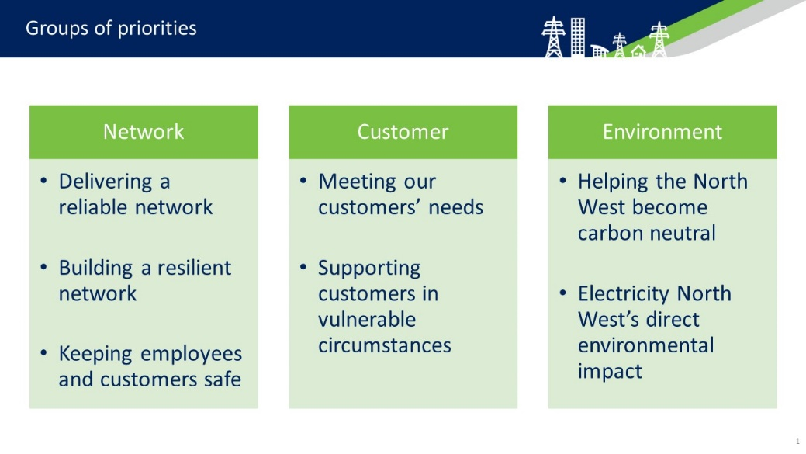By the sixth meeting of the Panel Electricity North West were able to present their Draft Business Plan Package to members. This was framed for members under the three business areas that they were familiar with and seven proposition streams (rather than the ten they had previously been considering).

After considering the range of specific initiatives that were included within the package under each proposition, members again had the opportunity to allocate a proportion of resources to each priority area.

6.3 Data from Panel 6 - Members allocating £10 of Electricity North West resources across the 7 propositions in the Draft Business Plan Package which they were presented with

Here investment in the three priorities within the network cluster were clearly prioritised for investment, together receiving over half the available funds. The remaining funds were split quite evenly between the environmental and customer clusters, although the previously demonstrated preference for investment in environmental improvements over customer service improvements was confirmed. Further detail of the reasons given for these preferences can be found in the later chapters in this report that focus on each service area.

## Affordability of Electricity North West’s Draft Business Plan Package

Members heard from Electricity North West about the impact the Draft Business Plan Package would have on bills and who that will affect the most.

#### Personal acceptability to members

The majority of members were supportive of the suggested bill increase of £9.80 as they believed the investments proposed in the package were necessary and provided good value for money. Many members stated that after all the conversations across the six sessions, they had a good understanding of the need for investment and noted that understanding the positive benefits of the bill increases made them happy to pay for it. Many members also noted that they saw it as a positive upfront investment in the future and felt an increase of less than £1 a month was a reasonable amount of money to cover this significant amount of work.

6.4 Panel 6 poll on personal acceptability of proposed bill increases

#### Fairness of proposed bill increase

Electricity North West informed members that wider customer research indicated that 80% of customers surveyed said they would find a £9.80 annual increase on their bill acceptable. However, they noted that they are aware that the 13.1% of customers in the region who are in fuel poverty may struggle to afford this. In light of this, members considered the fairness of Electricity North West going ahead with this bill increase to fund the Draft Business Plan Package.

6.5 Panel 6 poll on fairness of proposed bill increases

It was clear from the discussions that the trade-off between short term personal need and long term investment needs was the key consideration in evaluating the fairness of the suggested bill increase. For those who voted that they felt it was unfair, the main reason was the potential impact that would have on people already living in poverty. They further emphasised that this seemed unfair as it was an imposed cost that people had no choice over. For those members who were uncertain, the key point raised was that they felt any bill increase was a sensitive issue to discuss at the current time, noting that many people have been negatively socially and economically impacted by the COVID-19 pandemic.

When discussing how fair this increase would be, most members reflected that it was a small enough increase as to not have any major impact on most customers lives. However, of the minority members who did not think it was fair or were unsure, some suggested, given it was a small amount of money per month that customer bills would increase by, that the 20% of customers who in wider polling had said they would not find the £9.80 increase acceptable might be in such difficult financial situations that any bill increase would exacerbate this and should not be imposed. Further members took the view that the number of people polled who found the proposed £9.80 bill increase unacceptable would decrease if those customers were given the same information which this Panel had received. They suggested if more customers had the chance to learn what this Panel had and discuss the merits of various investments in a similar way, then they may well be likely to find the proposed bill increase acceptable.

The Panel also considered the option that Electricity North West could increase bills by a smaller amount, making the increase acceptable to more people, but understanding that this would mean Electricity North West cutting back on the initiatives outlined in the Draft Business Plan Package. When polled on this option 59% of the members supported proceeding with the proposed bill increase of £9.80.

6.6 Panel 6 preferred level of bill increase

£9.80 would be affordable. If folk will struggle with paying this, then we need to look at supporting them in other ways, and extra support should be provided to them from elsewhere

ENW should go for £10, as it’s a nice round number that can be easily communicated to the public, and they should put the 20p difference into a fuel poverty fund

ENW should go for £12, which makes a nice round £1 per month. It’s pennies we are talking about here

These findings show that whilst 75% of members felt the proposed £9.80 was fair, a smaller majority (59%) agreed with implementing that option despite 20% disagreement that it was acceptable. The fairness of a £9.80 bill increase clearly concerned some members as customers who financially struggling would have their lives made unfairly harder by a £9.80 increase, in this case the trade-off was to enable Electricity North West to fund some of the investments in improvement. Given the high levels of member approval of the £9.80 bill increase from a personal and fairness perspective, it is clear that overall the Panel were very supportive of the outcomes of the proposed investments that would be funded by the £9.80 bill increase. The main cause for concern for a minority of members was that the least well-off customers would be disproportionately negatively affected.

When discussing how to mitigate the challenge of the majority of customers approving of the £9.80 bill increase, but a minority finding it unacceptably high, two different groups suggested customers’ bills be means tested. The motivation for this suggestion was to allow the investments proposed in the Draft Business Plan Package, which were seen to be valuable by most of the panel, to be funded by the majority of customers who could afford that bill increase. Then by means testing bills, those customers who could not afford the bill increase would not be asked to pay it and could continue to have access to electricity to meet their needs.

# Network priorities

## Chapter Overview

Building on the analysis from previous chapters of members’ views on Electricity North West’s balance of priorities, how these should fit together in the Draft Business Plan Package and how these can be fairly paid for, this chapter looks in-depth at the network cluster of improvements.

As shown in Chart 7.1, 97% of members felt it was either very important or important for Electricity North West to invest in improving their network, demonstrating that members saw significant value in doing so. Members discussed the merits of twelve different options for investing to improve network performance and voted on how supportive they were of each option.

Only two options (‘Reduce the number of short (less than 3 minute power cuts’ and ‘Keep overall risk of the network where it is today with the same number of power cuts’) received less than 50% of support from members. Three options received over 90% support from members (‘Reducing the overall risk of the network in the long-term through replacing more old equipment before it fails’, ‘Replace the internal cables in high rise buildings to reduce fire risk’ and ‘Improve reliability for those customers receiving the worst service (multiple power cuts)’, with a further five options receiving over 80% support. This demonstrated a clear appetite from members for Electricity North West to invest in a wide range of improvements to their network. This chapter pulls out illustrative quotes from members which explained the key reasons why members valued these improvements so highly.

Members were consistent throughout in favouring Electricity North West investing further in the network, with a strong majority expressing a preference for Electricity North West to invest more to build up the resilience of the network and reduce risk (Chart 7.3). Members also considered if different customer groups should benefit most from investments to improve the reliability of the network (Chart 7.4). When given the option to allocate a nominal £10 across six customer groups, members spread their resources fairly evenly, showing that they could see value in all groups benefitting from investment in the network. However, Chart 7.5 shows that when asked to identify which group they wanted to see benefit the least from investment, 56% of members voted for ‘Low Carbon Technology (LCT) users’. This viewpoint is illustrated by member quotes outlining that, while they recognised use of LCT’s would be important in the future, they felt that these users had less pressing needs than the other customer groups highlighted to them.

## Network Investment

At Panel 1 and 2 members were presented with a range of potential initiatives and investment areas that Electricity North West were considering in the business planning process that could contribute to the 3 key network priorities.

* 1. Delivering a reliable network
  2. Building a resilient network
  3. Keeping employees and customers safe

At these meetings members learnt about Electricity North West’s current network performance and spent time considering the type of impact these different initiatives could achieve, alongside the implications investing in these activities for bill payers.

During Panel 3 the members returned to focus in more detail on the network cluster, specifically exploring how Electricity North West should balance risk and investment in building a resilient and reliable network, and then considering if particular groups of customers should benefit most from these sorts of investments.

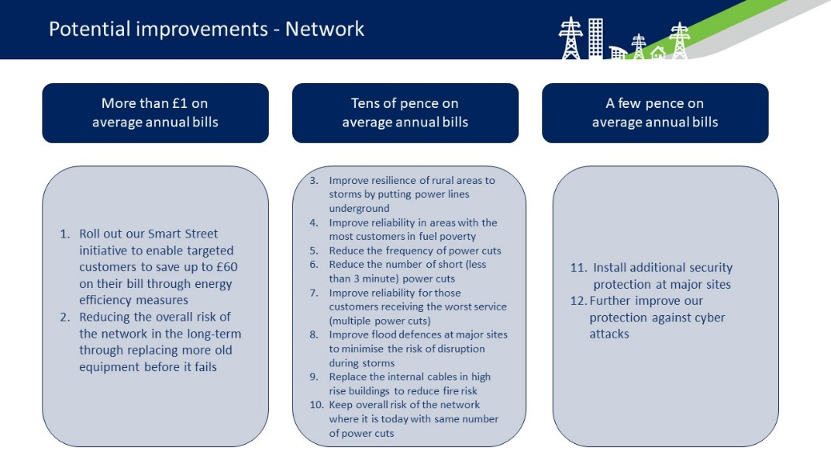

At Panel 6 members were presented with a Draft Business Plan Package which retained the three priorities they had been considering and included a range of propositions, many of which had been influenced by the Panel’s earlier discussions alongside Electricity North West’s wider engagement work.

This chapter will explore how important members thought it was for Electricity North West to invest in the network cluster, how their priorities changed and developed and their response to the propositions in the Draft Business Plan Package that were presented in Panel 6.

## Investment to improve network performance

When members were given information about Electricity North West’s network performance the majority responded very positively.

*It is good to see that ENW are among the best performers nationally.*

*I was delighted to see their performance was second best in the country*

7.1 From Panel 1

Despite high levels of agreement that Electricity North West appears to be performing well, more than half of the members indicated in an initial vote during Panel 1 that it was ‘very important’ for Electricity North West to invest in improving their network performance. A further 39% indicating they thought it was ‘important’, meaning a combined 97% of members viewed it as either important or very important. This leaves no doubt that members saw Electricity North West investing to improve their network performance as very important.

Following the opportunity to evaluate the different proposed initiatives, the members indicated individually their level of support for investment in each option. The results are shown below.

7.2 Panel 2 poll on levels of support for proposed network initiatives

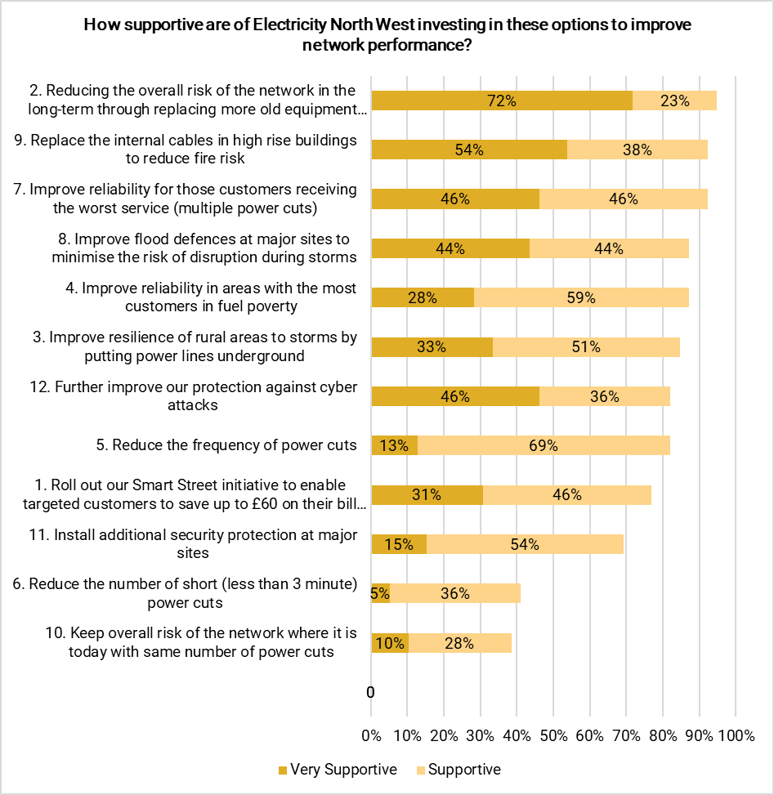

Initiative 2, ‘Reducing the overall risk of the network in the long-term through replacing more old equipment before it fails’, received the highest level of support (95% very supportive or supportive) and was identified by members as a clear investment in the reliability, resilience and safety of the network. It was also highlighted as a proactive investment that was of benefit to all customers. Despite being presented as one of the initiatives that would have the greatest impact on bills it was still widely supported, and members noted that they believed investment here would also support many of the ambitions presented in options 3–12.

Initiative 9 ‘Replace the internal cables in high risk buildings to reduce fire risk’ and initiative seven ‘Improve reliability for those customers receiving the worst service (multiple power cuts) were the second and third most popular initiatives with both having 92% of members either very supportive or supportive of them. Overall, more than 60% of members were supportive of all initiatives except 6 ‘Reduce the number of short (less than 3 minute) power cuts and 10 ‘Keep overall risk of the network where it is today with the same number of power cuts’. This demonstrates a clear appetite from members to see Electricity North West invest in a range of improvements to the network.

As discussed in the previous chapter, when members were given the opportunity at the end of the Panel meetings to indicate how they would prioritise the use of resources across the business area clusters (Chart 6.2), Network was the cluster which the Panel allocated the most resource to. Chart 6.3 further demonstrates that, when weighting up the specific propositions included in the Draft Business Plan Package this increased from 42% to 55% of the available resources. The rest of this chapter will focus on exploring the key reasons why.

#### Delivering a reliable network

In Chapter 5 it was highlighted that delivering a reliable network was ranked as the top priority for investment by the members at the conclusion of their meetings (Chart 5.2). Further, when considering the balance of resources needed across the seven propositions included in the Draft Business Plan Package members collectively gave the largest allocation (24%) to delivering on the initiatives proposed here (Chart 6.3).

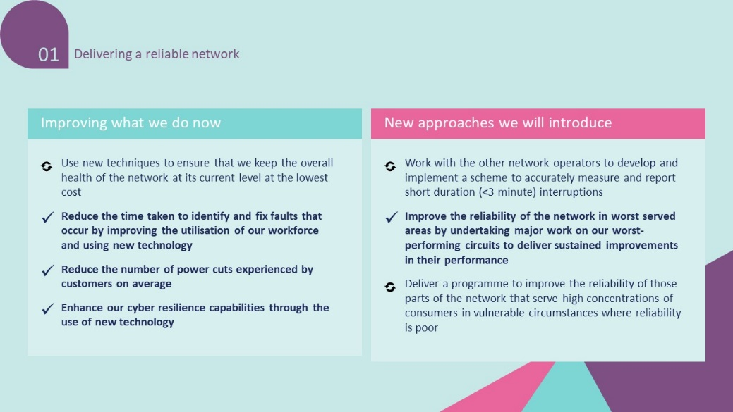

As outlined in Chapter 5, the reasons for members ranking Delivering a reliable network as most important of all were mostly themed around the essential nature of the service provided:

A reliable network has to be what everything else is built on.

Having a reliable network with equality of service to all across the region is fundamental for many reasons such as for home working, running a business, ensuring safety and for anyone who needs equipment for health issues.

The main reason customers pay ENW is to provide electricity everything else is secondary at best

Members also highlighted the negative expected knock-on impacts that not delivering this would have:

Without a reliable network we don’t have a [electricity] service, which would impact on all the other 6

Building a reliable network for excellent transmission, will address the other clusters issues indirectly.

A reliable supply is paramount and also impacts on vulnerable customers and will be more critical in the future as we decarbonise and switch to electric cars and other sources of supply.

#### Building a resilient network

When allocating resources across the seven propositions in the Draft Business Plan Package, in their final meeting the Panel allocated 20% to Building a resilient network, which was the second highest allocation (Chart 6.3).

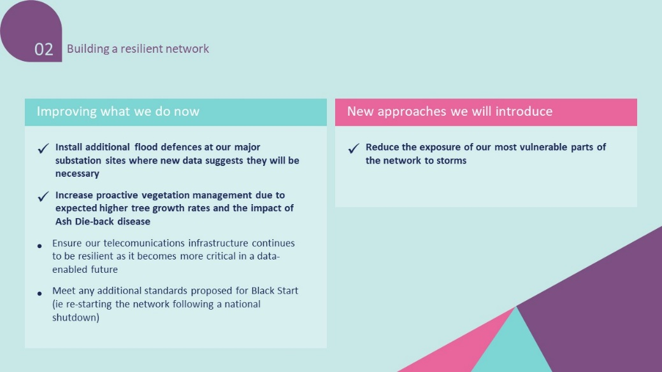

Many members saw this proposition as closely linked to reliability as both are fundamentally ensuring that customers have access to electricity whenever they need it.

A reliable network is essential. Power cuts are damaging particularly to the vulnerable and those that have medical needs. It can cause financial problems for businesses if the power cut lasts for a long time.

I consider options 1 [Delivering a reliable network] & 2 [Building a resilient network] to be mutually inclusive. I don't see how you can do one without contributing to the other. All other items are "incidental". I'm NOT saying that they should be ignored but, without options 1 & 2 there would soon be no network with which to "keep our communities safe", "meet your customer needs".

The main driver prioritising resilience appears to that members mostly saw it as the foundation upon which all other Electricity North West activities should be built. While the Panel did not identify Electricity North West’s current performance in these areas as particularly problematic, they still indicated that they preferred the most amount of investment to be in these areas due to their perceived importance.

Some members also highlighted other benefits of investing in Building a resilient network focussed on the positive long-term impact it would have on bills and the environment.

Building and investing in a resilient network I believe saves money in the long run.

Resilient network equals happy customers. Reduces carbon impact as less visits to maintain the network.

#### Keeping our communities safe

Safety was one of the top priorities for members at the start of this process, but by the end had become a less pressing concern for most (Chart 5.3). This was after they had learned about what Electricity North West already does and what the benefits of investing in other areas could be. That said, although the emphasis dropped during the life of the Panel, members still allocated 11% of resources to delivering on the initiatives presented under this proposition in the Draft Business Plan Package.

## Balancing investment and risk

In Panel 3 members spent some time hearing from Electricity North West on how the company currently approaches investment to mitigate risk to the network. This presentation also raised questions of prevention versus restoration as approaches to risk, highlighted what Electricity North West could do differently, and set out what the consequences of failure would be.

When asked about what approach they would like to see Electricity North West in balancing risk versus investment in the network, members were overwhelmingly positive about Electricity North West proactively investing to provide a reliable, resilient and safe network. As shown below, 49% said they favoured preventative maintenance of the network, 18% thought Electricity North West should invest a bit more to protect the reliability of the network and 31% thought Electricity North West should be investing as much as they can in improving the network.

7.3 Panel 3 Balancing risk and investment

Consistently, the two options which received no votes were ‘Electricity North West should repair faults as needed, limiting the additional spend to as little as possible (patch-up and make do)’ and ‘Electricity North West should retain a safe network by spending as little as possible right now and just dealing with faults as they arise (reactive)’.

These results strongly indicate therefore, that members favour Electricity North West investing in the reliability of the network, and valued that over saving money in the short term. Members clearly saw value in investing in the network and the majority were comfortable with these investments leading to an increase on their bill. This continues the notable trend of members preferring investment to improve over saving money on cheaper bills.

## Who should benefit most?

Having strongly indicated that they highly valued a resilient, reliable and safe network, and that they were keen to see Electricity North West continue to invest further in this area, members examined the question of if any particular customer groups should benefit most. This involved considering the different ways in which customer groups rely on electricity and how often they are affected by outages factoring in their geographical location in order to assess who they thought should benefit most.

To quantify this, members were asked to allocate £10 of resources between 6 identified customer groups to indicate which groups they thought should benefit most from investment in the network. Chart 6.3 showed that members could see value in investing to improve the network for all the groups. However, some groups were slightly higher priorities.

7.4 Panel 3, who should benefit from investment

In each case the reasons given for wanting to see particular groups benefit from investment in the network was to provide support to those who needed it most. Below is a flavour of the reasons given for members wanting to see investment in the network to benefit some of the slightly higher priority groups.[5]

* Fuel poor customers

Struggling customers should always come first

All the groups are worthy of investment but I think that by targeting fuel poor customers a large number of people who are already struggling and least able to cope with any more problems will benefit.

* Worst-Served customers

All customers pay the same amount. It is only fair and right that customers receive the same level of service as each other.

It's only fair that every receives a good standard of service, especially since we all contribute the same.

* Customers in vulnerable circumstances

There is a duty of care to ensure those who have the greatest need are taken care of as a priority

They are most likely to suffer serious harm in the event of a sustained power cut.

Overall therefore, it can be concluded that between them members saw reasons for all of the groups identified to benefit from investment in the network, but when pushed, prioritised those whose lives they felt would be most adversely affected by a network that was not resilient, reliable and safe.

It is also interesting to note that the lowest level of support was given to Low Carbon Technology (LCT) users. This is echoed in another poll taken at the end of Panel 3 where members were asked which group should receive the least focus when making decisions about investment in the reliability of the network. 56% of members indicated that this group were their lowest priority to benefit from investment.

7.5 Panel 3 lowest priorities to benefit from investment in the network

The reasons given by members in the discussions tended to focus on the expectation that whilst LCT users were likely to be important in the future, they were seen to be more affluent and have less pressing needs than other customer groups.

They are likely to be able to afford alternative solutions in the event of loss of power, especially more so than other customers.

It's a case of prioritising and whilst I fully support the move to LCT it is a conscious choice people have made and in doing so they accept the risks.

Although investment will need to be made for these customers in the future in my opinion they are best placed to cope out of all of the choices and can find alternative transport in the event of a power cut if they needed to get somewhere.

Having an electric vehicle is a positive standard, being affected by power outages or receiving poor quality service is a negative standard. Improve the negative not the positive as far as priority goes

While some members did acknowledge the importance of LCT’s in planning for the future, and expected them to become the norm, this was not reflected in the conclusions at this stage, despite the emphasis given to preparing for energy transitions and future electricity demand given in the final determination of priorities. The fact that this meeting took place before the consideration of these ‘futures’ explains this, but the results also emphasise some of the prejudices and assumptions that customers will make when potentially being asked to pay more on their bills to support future demand.

# Environmental Priorities

## Chapter overview

Following on from previous chapters members’ views on Electricity North West’s balance of priorities, how these should fit together in the Draft Business Plan Package, and how these can be fairly paid for, this chapter looks in-depth at the environment cluster of improvements.

Chart 8.1 shows that the overwhelming majority of members thought it was important for Electricity North West to invest in their performance in the environment cluster. The Panel also expressed a clear message that it was important to them as individuals that the North West reaches net zero (Chart 8.3). Members explored a variety of potential improvements which Electricity North West could invest in, the most popular options focussed around helping the North West achieving net zero (Chart 8.2).

Overall, actions which Electricity North West could take to lead the North West to net zero were very popular with members. This chapter places these findings in the broader context of where members most wanted to see investment and thought it was fair to increase bills for, as explored in Chapter 6. As seen in Chart 6.3, leading the North West to net zero was allocated the third most resources in the distribution exercise, notably less than the top two which focussed on delivering a reliable network and building a resilient network. The key reason identified for this was that Electricity North West should first and foremost perform its’ core function.

Additional to that some members were favourable towards Electricity North West doing what it can to lead the North West to net zero, but felt that there were other organisations that could, and should, have a larger impact. There was an acknowledgement by some members that leading the North West to net zero still left a lot of work to be done elsewhere by other organisations, which they were concerned about. Also, a small minority of members were concerned that money might not be best spent investing in these areas immediately, as they expected decarbonising technology to advance quickly and become cheaper.

Members also considered three options for non-decarbonisation actions that the company could take. They were mostly supportive of all of these actions and approved of Electricity North West taking responsibility for the impact it has on the environment. When discussing whether the company should start investing now to achieve these environmental improvements (leading the North West to net zero and non-decarbonisation actions), members also favoured a proactive approach to spread investment out across the next 45 years. They thought it was fair that all customers should pay for this, even if they were unlikely to live to see the benefits, as they felt this was a collective social responsibility to share the burden of paying for positive outcomes for everyone, similar to paying taxes.

Finally, members explored which customer groups might be at risk of being left behind by the energy transition occurring as part of the move to net zero. The three customer groups seen to be in need of the most support in this area were customers in vulnerable circumstances, fuel poor customers and worst served customers (Chart 8.9) as the harm done to them by being left behind was seen to be potentially most severe.

## Environmental improvements

At Panel 1 and 2 members were presented with a range of potential initiatives and investment areas that Electricity North West were considering in the business planning process that could contribute to the 2 key environment priorities.

* 1. Helping the North West become carbon neutral
  2. 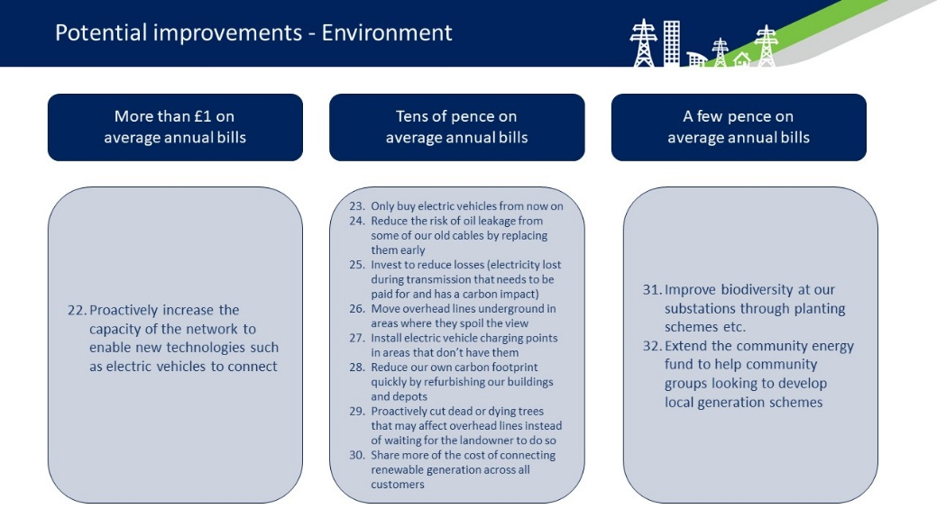Electricity North West’s direct environmental impact

At these meetings members learnt about Electricity North West’s current environmental performance and spent time considering the type of impact these different initiatives could achieve, alongside the implications investing in these activities for bill payers.

When taking a more focussed look at this topic during Panel 4, members discussed their own attitudes towards the North West reaching Net Zero by 2050, different options for to do so, non-decarbonising environmental actions Electricity North West could take and discussed who should pay for these. They also discussed the future use of electricity and how to effectively balance increased demand on the network without leaving any customers behind.

This chapter will analyse the outputs from these discussions and the importance members placed on these areas when voting after Panel’s consideration of the Draft Business Plan Package in Panel 6.

## Investing in environmental priorities

As discussed in Chapter 6, when members were given the opportunity at the end of the Panel meetings to indicate how they would prioritise the use of resources across the three clusters (Chart 6.2), Environment was the cluster which the Panel allocated the 2nd most resource to. Chart 6.3 further demonstrates that, when weighting up the specific propositions included in the Draft Business Plan Package 25% of the available resources were allocated to these initiatives – with 13% being prioritised for Leading the North West to Net Zero (the 3rd highest overall amount) and 12% to reducing Electricity North West’s direct environmental impact. The remainder of this chapter will explore how members arrived at these conclusions.

#### Initial Member priorities

Prioritising investment in Environmental performance was identified from Panel 1 as a priority for members. In the first Panel meeting 91% of members agreed that environmental performance was either an ‘important’ or ‘very important’ area for Electricity North West to invest in (Chart 8.1). Notably, this is a lower percentage than the Network cluster, but a higher percentage than the Customer cluster.

When asked to consider the relative priority for investment of the different initiatives proposed by Electricity North West, members ranked options 22, 25 and 32 as the highest priorities for investment. Notably all three of these options placed emphasis on proactively investing in Electricity North West’s capability to Helping the North West to become Carbon Neutral, for instance by focusing on enabling new environmental technologies to connect to the network, preventing electricity loss during transmission and supporting community generation schemes.

8.2 Panel 2 Environmental investment priorities

8.1 - Panel 1 importance of investing in environment cluster

The three lowest scoring options were 31, 28 and 23. In comparison to the top three prioritised options, these focused on internal changes Electricity North West could make to improve their environmental performance, for example by improving biodiversity at substations, refurbishing Electricity North West buildings and only buying electric vehicles.

## Leading the North West to Net Zero

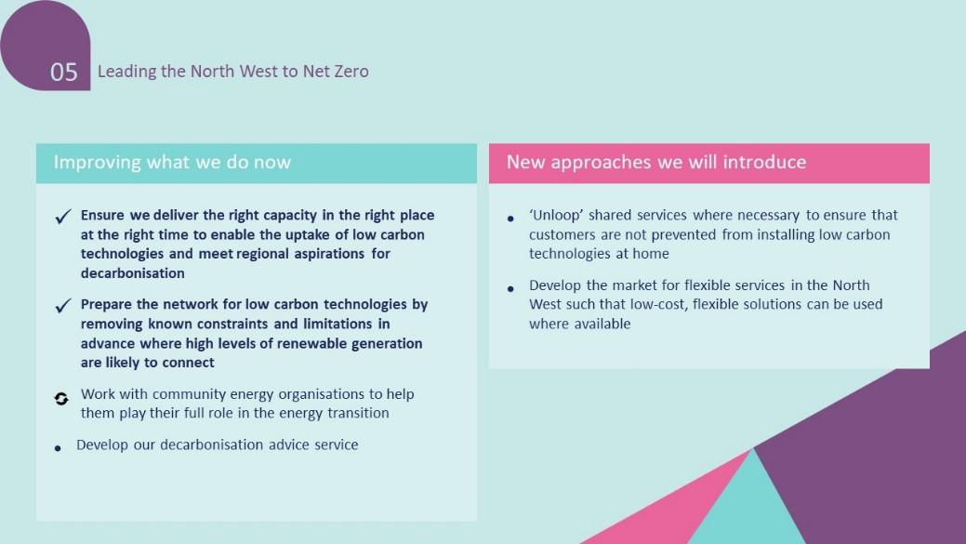In Panel 6 members allocated the largest proportion of the resources they gave to the Environment cluster to this proposition, allocating 14% (Chart 6.3). Despite being a lower allocation than most of the Network priorities this shows the significant focus given to the need for Environmental investment by the members.

The members’ reasons given for prioritising this set of propositions focussed on the scale of impact, both in terms of what Electricity North West could do to help reach this target, and the scale of impact it would have on other priority areas. Some members emphasised the urgent need for action in reaching Net Zero:

ENW has unrealised potential for helping the North West to net zero. If it can make it vastly easier for community energy projects, then they can produce more of their own electricity and reduce pressure on the mains electricity overall.

we NEED to focus on the environment or we're going to have bigger problems and it will cost us more in the long run, impacting other areas greatly

Whilst other members explained why they had allocated the most of their £10 to helping the North West reach net Zero by emphasising the way in which achieving this could have further positive impacts in other areas if Electricity North West was a leader in this area.

Helping the North West become carbon neutral is most important to me since it has been overlooked for years and I feel like it now deserves priority given the urgency of the climate crisis… Delivering on carbon neutrality will make bills cheaper and the network more reliable, thus killing two birds with one stone, so prioritising the environment also represents good value for money.

I believe it’s worth investing more money now to save money long term. I also think we should be leading the way, hopefully encouraging other large organisations to follow suit in reaching or exceeding local and national targets.

I think by attending to the environmental issues this will help you to have a more reliable network and in turn this will improve customer satisfaction.

In Panel 6, when dividing up resources amongst the seven propositions presented as part of the Draft Business Plan Package, Helping the North West become carbon neutral was the top environmental priority. Even for the members who did not allocate the largest segment of their £10 to this proposition, it was clearly still a target which they thought it was important to achieve, as shown below, with a combined 90% ranking themselves as a 7-10 on that scale.

When combining the data from Chart 8.3, which shows members expressing that it was important for them that the North West reaches net zero, and the data from Chart 6.3 it shows members wanting to see Electricity North West invest less in this area than ensuring a resilient and reliable network. The primary reason for this was set out in Chapter 5, with members making clear that they thought a reliable and resilient network was the foundation upon which all other actions by Electricity North West could be built. Additional to that, these results of valuing the North West reaching net zero, but allocating it the third most amount of money behind delivering a reliable network and building a resilient network, can be interpreted to be primarily motivated by two key factors.

8.3 Data from Panel 4 on the North West reaching net zero by 2050

Firstly, some members consistently made it clear in their group discussions and explanations given for how they voted that, whilst they valued Electricity North West playing their role in the North West reaching net zero, they thought there were other organisations, such as governments (domestic and foreign) and fossil fuel industries who would have much larger roles to play in this than Electricity North West would. This was focussed around the level of impact that Electricity North West could have.

From the UK perspective we need to do SOMETHING to reduce carbon emissions for the welfare of the UK population. If you look at the UK from a Global perspective we are ranked 16 (out of all the countries in the world) for carbon emissions. This equates to producing just 1.02% of world global emissions, with China, the USA and India way out in front with 29.34%, 13.77% and 6.62% respectively (2017 figures). Unless and until these countries make significant changes to their life styles NOTHING we can do will slow down or stop global warming.

The second factor is some members being wary of investing heavily early on in the path to net zero as they anticipated that technology would be developed which would make the transition much easier, and potentially cheaper.

In realising this target you need to keep a sense of proportion. Better ways of achieving the target will come to light as time progresses so it usually doesn't pay to invest heavily too early.

Both of these factors help explain why the principal of the North West reaching net zero was very popular with members, but this did not translate into them prioritising that over delivering a reliable and resilient network.

### Pace of change towards Net Zero

During Panel 4, members considered four different options for how quickly Electricity North West should make the changes to the network that are needed to reach Net Zero. They discussed the pros and cons of the options and made clear that they’d like to see Electricity North West moving quickly towards net zero and leading the way in the North West.

8.4 Data from Panel 4 on individual preferences for Net Zero timeline options

The majority of members expressed a preference for the most ambitious timeline for Electricity North West reaching Net Zero, focusing on the 2038 deadline. Members explained their reasoning for this as driven by significant worries they had about the environment.

I think it is important that action is taken now to reduce carbon emissions, painful and costly as it may be, it is our duty to act as quickly as possible, putting it off may leave it too late to deal with the environmental issues we are creating daily.

Improves humanities carbon reduction sooner which is an absolute necessity

We're going to have to make huge moves towards this sooner rather than later and I think it will cost more to react than proactively invest. We don't have time to be discussing 'the cost'. The cost is life as we know it is about to change forever and has already started to. We need to act as quickly as possible, not just as much as we're comfortable with. We need to act now and to act quickly for our own sakes and our children's sakes.

Other members also saw the trajectory of aiming to reach Net by 2038 across the region as allowing a degree of flexibility to deal with unforeseen circumstances.

Targets are rarely met, 2038 gives wiggle room to reach 2050 if necessary.

The fact it has to happen that sharply makes me feel this is something that needs to be acted on quickly. In that sense, I don't think slowing down improvements to meet 2050 is smart. There will be setbacks and unexpected events that put a spanner in the works, delaying the time more. Then, it may be well after 2050 that it's completed. No less the fact some may not live to see this change. I think the 2038 trajectory is the best option.

This would be the ideal, however the damage to the planet needs reversing, the 2038 target should be aimed for to get it done as soon as is possible, however the 2050 target gives room to improve on that which has been done but could be further improved upon

This further demonstrates the collective view of the panel that Electricity North West should be ambitious in playing its’ part in the North West reaching net zero. 58% voted for the most ambitious target that Electricity North West could set itself and only 15% voted for the least ambitious option.

### Decarbonising options

Whether motivated by a belief in the need for as urgent as possible action, or by the value of aiming to get ahead of the 2050 national target in order to allow for some ‘wiggle room’, the majority of members favoured Electricity North West’s driving to reach the Net Zero targets in parts of the region by 2038.

To explore possibilities for how this should be done, Electricity North West presented members with four key decarbonising options which they could focus on to achieve this goal.

1. Smart Street initiative
2. Investing in the network
3. Energy efficiency advice and support
4. Enhanced support for local and community groups

When looking at these decarbonising options, many members were enthusiastic about Electricity North West investing more, and investing quickly, in these areas.

We can’t spend time choosing, we need to go ahead with all 4 options. Rapid change programme. As a customer, I am prepared to pay more. We have to all do our bits. Can’t wait. ENW needs to step forward as an organisation

### Allocation of resources across decarbonising options

When invited to make a judgement about the percentage of resources that should be allocated to a range of decarbonisation activities – using the idea of distributing £10 of the money Electricity North West has allocated to help reach net zero – members opted for a fairly even distribution.

8.5 Data from Panel 4 on decarbonisation options resource allocation

There was, however, a small preference expressed towards ‘Invest in the network to enable the uptake of technologies such as electric vehicles and solar panels’ which was motivated by some members feeling there to be a need for Electricity North West to keep up with rapidly developing technology.

Investment in the existing network is vital to ensure it keeps pace with requirements and facilitates the use of new technologies to reduce carbon emissions, as well as maximising energy efficiency.

Clearly, our world is changing at a rapid speed. We need to make sure the network can cope with all the changes that are going to take place over the next few decades. We are undoubtedly going to have problems when we all start using more electricity so, investing in the network we hopefully will encounter less major problems.

Members also emphasised the importance of empowering local communities.

I'm very much in support of empowering local communities to take responsibility and create their own renewable energy for their areas. I feel that communities should be able to lead and make more decisions in how their area is supplied and be able to contribute towards that. We should do all we can to empower grassroots groups and organisations that want to help make these changes.

Whilst members took varying views on how concerning potential bill increases to pay for these investments would be, there remained a strong support for Electricity North West proactively taking action to help the North West achieve net zero.[6]

Push as far as you can. £12M costs in total: equivalent to a £1 increased bill a month is not excessive.

We can’t spend time choosing, we need to go ahead with all 4 options. As a customer, I am prepared to pay more. We have to all do our bit.

As referenced above, there was clear enthusiasm for Electricity North West to take a proactive role in helping the North West achieve net zero. This should be understood in the context of how members allocate £10 across the seven proposition areas in Chart 6.3 where this proposition was allocated the third most funding by members, behind delivering a reliable network and building a resilient network. These were something which Electricity North West were seen to have significant control over, whereas some members were less confident about Electricity North West’s ability to have the same level of positive impact in the North West reaching net zero.

## Addressing Electricity North West’s direct environmental impact

In Panel 6 a small number of members allocated the largest amount of the resources at their disposal to Electricity North West managing their direct environmental impact. The reasons given for this touched on themes of individual values, corporate responsibility and the need for urgent action.

The environment is the most important criteria in my opinion there is already a resilient network, consumer protections in place, and a mechanism to aim to protect the most vulnerable - but the environment needs urgent attention

I think it's time corporations took direct responsibility for their impact on the environment. It is often placed on the customer - reusable straws, bags for life, etc - when the majority of these environmental impacts come from large companies.

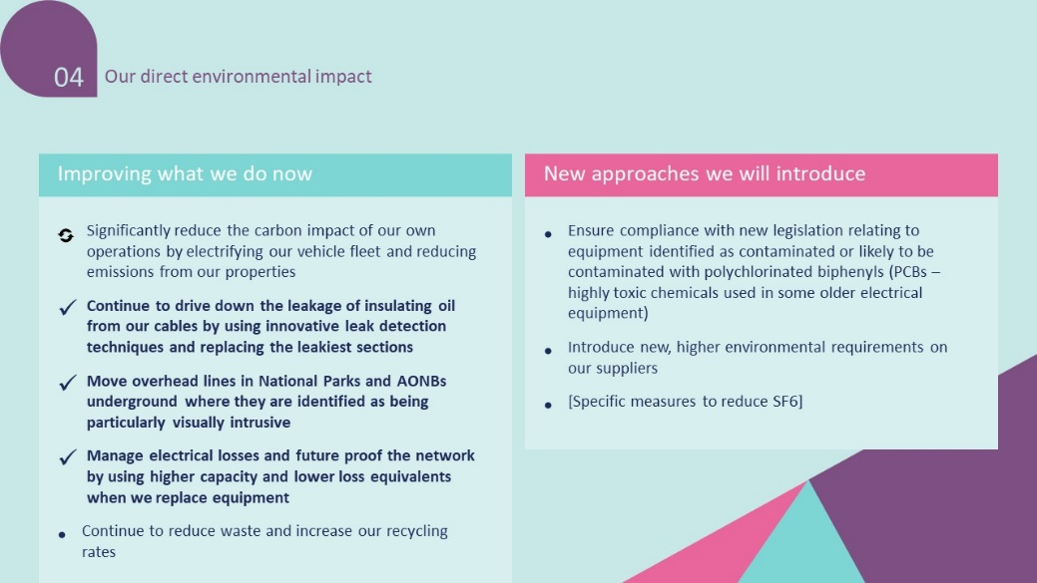While there was general support for the company reducing the carbon impacts of its operations - by updating its fleet, reducing waste and excess energy use at its office and other facilities, and by improving the biodiversity on sites that it manages – there was also considerable support displayed by the Panel for a range of other environmental measures proposed by the company that were not focussed on decarbonisation.

### Non-decarbonising environmental actions

In Panel 4, members heard from Electricity North West about a range of non-decarbonising environmental actions that they could take to help reduce the impact of the company’s own operations. The three key options presented were:

* + 1. Putting cables underground in areas of outstanding natural beauty
    2. Reducing the environmental impact of oil leaks from cables
    3. Reducing the environmental impact of when Electricity North West cuts down trees

Members heard from Electricity North West about the impact that Electricity North West taking these actions could have, discussed them in small groups and were polled on how important they thought each action was. As shown in Chart 8.6. Reducing the environmental impact of when Electricity North West cuts down trees was seen as most important.

8.6 Data from Panel 4 on non-decarbonisation options

* For those advocating for the need to **place wires underground in areas of outstanding natural beauty** this was an important measure in and of itself, although other members noted that this measure could also contribute to the resilience of the network in regional areas.

This is extremely important to me. There’s the plus for efficiency and ease of maintenance but I think it would do a lot for the long run, especially considering that ENW are looking at usage maybe being tripled as well as improving services for rural living people. To continue adding pylons and overhead lines would ruin the beauty that’s left.

* Regarding **oil leakages**, those who considered this a very important action largely cited environmental protection and the dangerous and harmful impact of oil leakage on the environment as their primary reasons.

Oil leakages, no matter how small, can have a devasting effect, from killing plants to polluting rivers and streams, therefore harming wildlife, from fish to animals to birds who rely on plants and insects as a food source

* Regarding the need for **trees to be chopped down or pruned** to enable maintenance work, members favoured a balance to be found between the need to cut trees to protect the network and the importance of replacing trees given their value for wildlife, the ecosystem and as agents of carbon capture.

Trees play an important role in the wildlife in this country, so whilst it is essential for the network not to be damaged from trees, there needs to be a balance that respects wildlife

There was clearly strong support for Electricity North West to take the three non-decarbonisation environmental actions. The issues raised by Electricity North West were seen by the panel to be important and having a harmful impact on the environment, so worthy of addressing. This fits within the broader them of members thinking it is important for Electricity North West to avoid having a negative impact on the environment, through helping the North West reach net zero and by addressing issues such as oil leakage. These actions were something Electricity North West can control and are therefore something that members would like to see the company take active responsibility for.

## Paying for improvements

Having learned about the expected increase in demand on the network that are likely to come due to the need for decarbonisation, the members considered who should be paying for the investment needed to ‘future proof’ the system in order to manage the expected increase in demand.

8.7 Panel 4 Pace of investment

The results above demonstrate a clear desire from the Panel for Electricity North West to start investing now in order to prepare for a decarbonised future to help the North West reach Net Zero. Much of the reasoning for doing so centred around the duty members felt to help future generations by taking on extra cost now themselves.

Because I'm thinking about future generations and I would like to leave this world feeling that it is a more environmentally friendly place. I could hear more birdsong during Lockdown and I would like to hear as I leave the world

Why not. The benefits may not be immediately available to me, or even my children, but generations further on will benefit from MY investment NOW.

When specifically asked about the fairness of all customers paying the same amount for improvements to help reach net zero, members considered if it was fair for older customers to be paying for improvements that they may not live to see the benefits of. The majority of the Panel (73%) felt that it was fair for everyone to pay the same for improvements to help reach Net Zero, with only 6% thinking that everyone should not pay the same.

8.8 Panel 4 Balance of payments

The reasons members gave for thinking everyone should share the costs hit on a number of themes. These themes included viewing increased bills as taking on a collective social responsibility for a positive outcome, fairness, equity and also practicalities of charging people differently based on the amount they would benefit.

We do this for our water and Council tax I am retired so will not see the long term benefits but younger members in my family will.

It’s our duty as a collective, we have generally all contributed to the situation we are in and can only do it if everyone pays.

We all benefit from changes in the system and those who are older who won’t benefit from the next 30years have already benefited from improvements over the past 30years paid for by their elders.

Whilst there was very strong support for everyone splitting the cost of these investments equally, there was a minority of members who thought that equally splitting the cost amongst everyone was not fair. The reasons for this view highlighted concerns about the potential impact of bill increases on people with lower incomes, beliefs that wealthier customers should pay more than those who are less well-off and fairness across the size of households.

I think that we will all benefit greatly from these initiatives and so should all pay towards it, I'm just concerned about those from lower incomes being negatively affected by this. Those that are more affluent should pay more or those on much lower incomes should pay less towards this.

Richer people should pay more because if it was balanced by percentage it should be about what people earn as to what the costs is and spread it out that way

A single person shouldn't have to pay the same as a larger household.

This raises challenges of achieving fairness across the spectrum of customers now as well as fairness for customers in the future. However, the majority view was that it was fairest for everyone to pay the same, even if they would be unlikely to see the longer-term benefits.

## Making sure no-one is left behind by the energy transition

After hearing from Electricity North West about the need for usage of the network to be managed more effectively, members discussed their willingness to adapt their behaviour, how others might be encouraged or incentivised to do so and how to ensure no customers are left behind by this energy transition.

Broadly the Panel took the view that customers more broadly should, and would, adapt their usage of the network if they understood the benefits and consequences of not doing so.

*We are all changing our behaviour in terms of being more energy efficient. When buying appliances and bulbs etc. because it saves money and is good for environment.*

*If people could see the benefits of changes, then they might be more willing to do this.*

Although there were some questions regarding how easily implemented this sort of change could be, particularly fitting customers diverse needs.

*Different households will have very different needs / use of electricity. Some folk won’t be able to flex their use, because of things like work/family patterns.*

*It’s a privilege to be able to change your whole schedule… and my kids have demands. We are creatures of habit.*

*It would be nice to have a personal home pattern that I could manage my electricity around; my usage varies quite a lot.*

Some members were also uncomfortable with the possibility of having their appliances automated.

*I’d be worried about use of technology to determine when you can have your washer on etc. I want the option to take responsibility myself.*

*Discomfort around someone else controlling my appliances - being told you have to do your washing at X time is not practical*

Having been broadly open to the idea of adapting their usage of the network, but holding some concerns about how this could be implemented, members then discussed what they thought might make this behaviour change more attractive to more customers. The key themes highlighted were the need for effective education and financial incentives such as varied rates for electricity usage. Members also expected other customers to be unlikely to immediately engage with letters from Electricity North West given low awareness of their role and therefore keeping things as simple as possible would be most effective.

*I would be willing [to adapt my consumption], wouldn’t want to be paid for it but would like some benefit. e.g. lower rate for using electricity in the evenings, higher at peak.*

*I’d like to do this, but I’m not well off and I don't have equipment that can work overnight.*

*Need to simplify things to get people to change habits. Need one supplier [as] a lot of people are confused; a lot of companies are making money out of it.*

*It’s just electricity. A lot of stress from complexity. The simpler the better.*

Members also discussed if any particular customer group should receive particular support from Electricity North West to ensure they were not left behind by this energy transition. As seen in Chart 8.9 there were three customer groups which were identified as the most important to be supported by Electricity North West to make sure they are not left behind by the energy transition: Vulnerable, Fuel Poor and Worst Served customers. This demonstrates the consistent view from the Panel that the groups who they saw as having the most pressing need of support in living decent lives were most important to be providing support to. Overall plenty of other customer groups were seen to be deserving of support as well, but were clearly ranked as lower priorities than the top three groups.

8.9 Panel 5 making sure no-one is left behind. borda count, 1st place vote = 8 points, 7th place vote = 1 point, 8th place vote = 0 points

# Customer Service

## Chapter overview

This chapter explores members’ views on Electricity North West’s customer cluster of potential improvements, which were explored during Panel 5. Members outlined their overall level of satisfaction with Electricity North West’s level of customer service based on what they had learned. As seen in Chart 9.2, members were broadly satisfied with the level of customer service, with there being a slight leaning towards a small increase in investment. This was also reflected in Chart 9.3 where a combined 95% of members said they agreed or strongly agreed that the five steps in the core customer journey offered the right level of communication during a power cut. When asked which of the five steps members thought were most important, there was a spread of opinion. The option most commonly voted for as the most important in the customer fault experience was ETR from site, with 34% of the vote.

Members also discussed the customer service which Electricity North West provides during a power cut. Just fewer than half of members said they wanted to see an increase in investment from Electricity North West in this area (Chart 9.5). This broadly mirrors the outputs in Chart 6.2 and Chart 6.3 which suggested that the customer cluster was a lesser priority for the Panel overall compared to the network and environment clusters. When exploring how customer service during a power cut could be improved, the most common themes raised by members were surprise that Electricity North West is reliant on customers to inform them of a power cut and also that the customer fault experience would only begin if a customer got in touch, which would mean those who didn’t know to contact Electricity North West would be left in the dark during this process.

Members also explored a variety of possible options for improving Electricity North West’s Priority Service Register (PSR). When considering options for recruitment targets for the PSR and improving the data on the PSR members were most positive about more ambitious and comparatively most expensive options (Chart 9.6a and Chart 9.6b). Much of the reasoning members gave for this centred around the feeling that the service which Electricity North West is a good one, but too few customers were currently making use of it due to a lack of awareness of it. When discussing specific support which could be given to PSR customers during a power cut, opinion was split across the panel, but the most popular two options were increased telephony support as it would reassure people and providing additional amenities to meet people’s basic needs (Chart 9.6c).

When members discussed options for supporting customers who are in fuel poverty, 53% of members voted for the most ambitious and expensive option which would see the company take a proactive approach to supporting these customers (Chart 9.7). This was particularly motivated by two key factors, firstly members expected that more customers would be in fuel poverty due to the impact of Covid-19 and secondly many members felt that, overall, the Panel was recommending increases in bills, so customers in fuel poverty might need extra support. Finally, members explored how Electricity North West could protect vulnerable customers and ensure no-one is left behind by the energy transition. There was no strong consensus on which of the suggested options was most preferable, with three options receiving around 50% support (Chart 9.8). Only 8% of members voted for ‘none of the above’ which indicates that in the panel there was an appetite for some action to be taken in this area, but there was not agreement on the best type of action to take.

## Customer Service Priorities

At Panel 1 and 2 members were presented with a range of potential initiatives and investment areas that Electricity North West were considering in the business planning process that could contribute to the 5 key customer service priorities.

1. Providing value for money
2. Keeping bills as low as possible
3. Meeting our customers’ needs
4. Supporting customers in vulnerable circumstances
5. Raising awareness

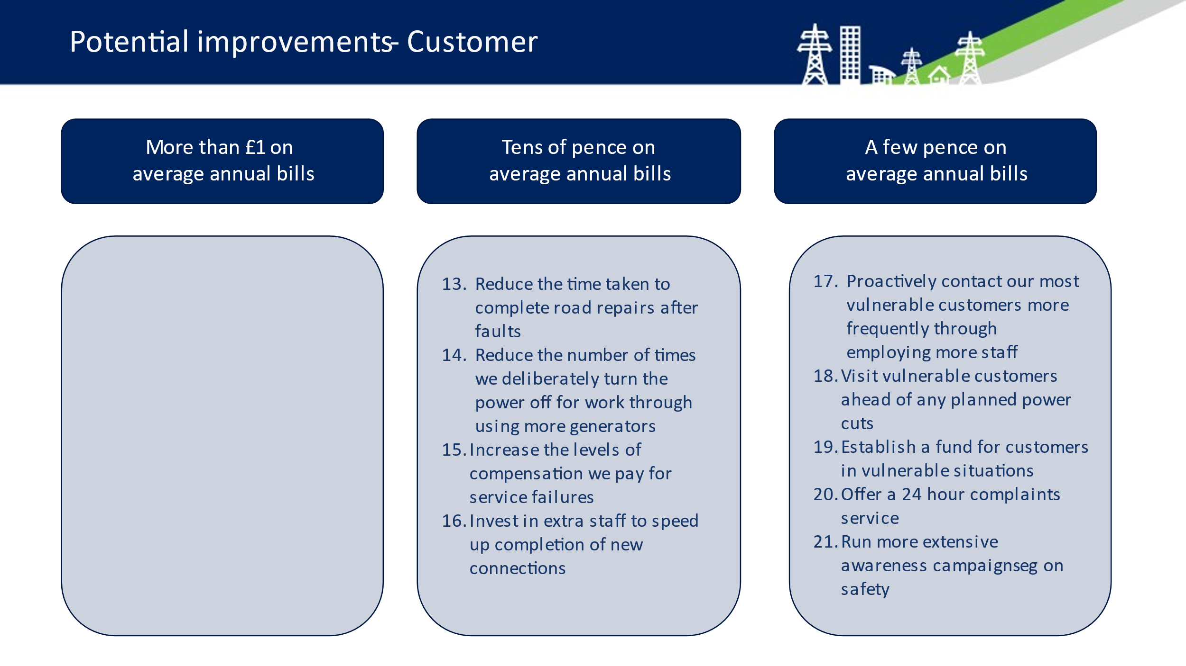At these meetings members learnt about Electricity North West’s current performance in terms of customer service and spent time considering the type of impact these different initiatives could achieve, alongside the implications investing in these activities for bill payers.

. Options for improvement on Customer

At Panel 6, having been informed by the Panel and wider engagement, Electricity North West had refined these to being two of the seven propositions focussed on customer service.

1. Meeting our customers’ needs
2. Supporting customers in vulnerable circumstances

This chapter will explore how important members thought it was for Electricity North West to invest in the customer cluster, how their priorities changed and developed and their response to the propositions in the Draft Business Plan Package that were presented in Panel 6.

## Should Electricity North West invest more in customer service

Members discussed in small groups their views on how Electricity North West currently performs in terms of general customer service. After discussions in small groups, the Panel was fairly split, with some suggesting Electricity North West should be looking to catch up with or get ahead of other companies in the industry, whilst other members tended to broadly satisfied with how Electricity North West currently performs.

During an exercise in Panel 5, members positioned themselves on a spectrum from 0-10 to reflect whether they thought Electricity North West should invest more, less or the same amount in customer service overall.

Chart 9.2 shows that when members were asked if they would like to see Electricity North West invest more money from their bill to improve customer service, that on average members were comfortable with the current level of investment in customer service not being changed. 27% members identified their view as a 5 on this scale, meaning that they would like to see investment in this area remain the same. A combined 46% members placed themselves as either a 6 or 7 on this scale, indicating that they would like to see a small increase in investment in customer service. Small numbers of members placed themselves higher and lower on this scale but the most common view was that Electricity North West should either maintain their current level of investment or increase it a small amount to improve customer service.

9.2 Panel 5 - investing more in customer

## The 5 steps of the customer fault experience

Having discussed Electricity North West’s performance on customer service in general, members then took a more detailed look at the 5 steps of the customer fault experience which occur when there is a power cut reported. The aim of this was to explore which of the five steps were seen as most important and consider which might be most worthwhile investing further in.

The five steps in the customer fault experience outlined by Electricity North West were:

1. Fault logged
2. Job dispatched
3. Staff on site
4. Estimated Time of Restoration (ETR) from site
5. Permanent restoration

9.3 Panel 5 communication during a power cut

After discussing them in their groups, members were asked if they thought these steps offered the right level of communication during a power cut. As Chart 9.3 shows[7], almost all of the Panel thought that the five steps did offered the right level of communication during a power cut.

I think this is the right level of communication and that people definitely need to be updated throughout to maintain customer satisfaction. Customers are less likely to take issue with the progress of fixing an issue if they understand why things might be taking longer or get updates that something is happening.

This is a well relayed method of resolving the fault experienced by the customer. From my perception it is a swift methodology of faults resolve, however the job going to be done must be explained to the customer before dispatch of the job

Three people voted to say they strongly disagreed with the statement that the five steps in the core customer journey offered the right level of communication during a power cut. However, when the worksheet asked them to explain why they thought that, their answers appeared to explain why they might strongly agree with the statement, rather than strongly disagree, suggesting they may have misread the question.

it is the correct continuum of response keeping the customer informed

Excellent steps by seeing through from start to finish. To further improve maybe request a customer feedback at the end to see how you did.

I think once you are aware of the fault these steps are enough to keep the customer informed without over communicating and annoying them.

Members also voted on which of the five steps they believed was most important. As shown in Chart 9.4 the step which the most members thought was most important was ETR from Site. The reasons members gave for thinking this step was most important centred on the ability it would give them to plan around a power cut with as few major issues caused as possible.

This would enable me to plan what I need to do for the duration of the power cut.

Timescales reduce anxiety

Having an estimated time of reconnection is vital for planning purposes i.e. if it's going to take several hours, then the customer can adapt to that and make changes as necessary

However, votes were relatively evenly split across the other four steps. This suggests that the combination of those five steps is important.

9.4 Panel 5 Which step is most important

Key reasons given by members who thought one of the other five steps was most important are shown below.

**Fault logged: Thanks for calling, we've logged your power cut and one of our team will be dispatched soon.**

Primary requirement if not achieved the other steps will not happen

You know the situation is in hand and something is being done to resolve the situation.

**Job dispatched: We have a team on the way**

This is when you're internally satisfied something has been done about your communication.

So the customer knows the fault is being dealt with

**Staff on site: Our team is on site and we're investigating**

I think once I knew someone was actually working on site to restore my electricity I would feel that the problem would soon be resolved.

With many different companies, the first two points above are pointless, it is only when the staff are actually on site that you know something is being done.

**Permanent restoration: Great news, we have fixed the problem and your power is restored**

Fault logged and staff on site etc would also be important to me but permanent restoration would be even better. Also it would be dependent on the length of time of the power cut and also the time of day. Any power cuts I have had have been an inconvenience rather than serious but I am aware of how serious they can be for others

power back on and service continuing as normal is what all your customers want as soon as possible

## Improving customer service during a power cut

When considering how customer service during a power cut could be improved, some members expressed surprise that Electricity North West relied on customers getting in touch to inform them about a power cut. Other members also noted that whilst the five steps of the customer fault experience offer a good level of customer service, these were only for customers who contacted Electricity North West to report a fault, leaving others uninformed.

It doesn't say about contacting people who haven't called who would be affected

Drawing upon their previous discussions about not having necessarily known about Electricity North West prior to being part of the Panel, this highlights a risk that Electricity North West works to provide a service which members approved of, but many customers are not aware of and are therefore unable to benefit from. When discussing if Electricity North West should invest to improve customer service during a power cut specifically, opinion remained split as shown in Chart 9.5.

9.5 Panel 5 Investing in customer service during a power cut

Less than half of the Panel were sure they wanted to see Electricity North West invest more money to improve customer service during a power cut, however 24% said they were unsure. This broadly mirrors the Panels view on investing to improve customer service in general. This question of further investment split opinion on the Panel and, as shown in Chart 6.2 and Chart 6.3, when allocating resources across the clusters, and the priorities which sit within them, improvements focussed on customer service were given the least funding of the three clusters.

Of those who did think Electricity North West should invest more money to improve customer service during a power cut, their reasons mostly focussed on one of these five themes:

* Making customers aware that they should contact Electricity North West when there is a fault

Informing the customer about who to contact during a fault, and knows what to expect such as social media, mainstream media and effective telephone system for the customer to access without difficulties

* Electricity North West ensuring it knows about faults ahead of customers having to call up to tell them

Improve local power monitoring so that outages are automatically fed back to ENW rather than waiting for a customer to report it.

* Electricity North West getting hold of customer information and proactively contacting them

Contacting all customers. ENW can achieve this by allowing an opt-in to share details when a customer fills out a form for a new electricity supplier.

* Providing practical support during power cuts

Compensation and help during the time down.

* Supporting customers in vulnerable circumstances

Focus on those who don't have mobile phones and who cannot access email - probably mostly older generations though they probably won't be waiting to do some work it can still majorly upset their routine and make them worry excessively.

## Priority Service Register

Members learned about Electricity North West’s Priority Service Register (PSR) and how it offers extra support to different groups of customers during power cuts. They explored three key areas for how it could be improved and considered different levels of investment in these areas and the impacts those would have.

The three areas explored for improving the PSR were:

* PSR recruitment targets
* Improvements to PSR customer data collection
* Support for PSR customers during power outages

### PSR recruitment targets

Members discussed and voted on what percentage Electricity North West should have as a minimum recruitment target for customers who are eligible to be on the PSR per area. The options proposed by Electricity North West were:

1. Over 80% of customers, costing 22p more per year for every customer
2. 70% of customers, costing 16p more per year for every customer
3. 60% of customers, costing 10p more per year for every customer
4. There is no need to invest more in getting people onto the PSR

As shown in Chart 9.6a below, the majority of members were supportive of the most ambitious recruitment target to the PSR, 80%, which would cost each customer 22p more per year. This suggests a similar theme to the point made by members about the five steps of the customer fault experience; that the service Electricity North West offers is good, but too few customers are aware of it in order to benefit sufficiently.

Some members felt that it was Electricity North West’s responsibility to ensure that as many eligible people should be on the register as possible, noting that 22p extra is not very much to provide a better experience for more Electricity North West customers. Indeed, some members emphasised Electricity North West should be aiming for 100% recruitment to the PSR to ensure no one “slips through the net” or “is left behind”. Members noted supply companies should take responsibility to share information with Electricity North West and that customers should consent to their data being shared.

Additionally, some members highlighted that expanding recruitment to the PSR would raise customer awareness of Electricity North West. Many felt more customers needed to be aware of the PSR and this expansion would help with that.

However, some members noted customers might not want to be on the register as they might not consider themselves vulnerable, making a target of 100% not realistic. It was suggested the PSR could be “opt-out” rather than “opt-in”, with comparisons between this and organ donation mentioned.

.a Panel 5 - PSR recruitment targets

Data improvement of the PSR

Members were similarly positive about Electricity North West investing more and setting more ambitious targets when considering how often Electricity North West should be contacting customers on the PSR to ensure the data held on them was correct so Electricity North West is able to effectively support them when needed.

Members discussed and voted on how often Electricity North West should be contacting PSR customers to check their data is correct and that they want to remain on the PSR. The options proposed by Electricity North West were:

1. Contact 100% of PSR customers every 2 years - 15p per annum
2. Contact 100% of the HIGH category (electrical dependant) every 12 months and   
   - all medium / low PSR customers every 2 years - 27p per annum
3. Contact 100% of HIGH category (electrically dependent) and - MEDIUM every 12 months and - low every 2 years at cost of 41p per annum
4. Leave it as it is
5. Other

As shown below in Chart 9.6b, the two most popular options when voting on this were the two most ambitious options. The key distinction between the most ambitious option, which was voted as second most popular, and the second most ambitious option, which was voted as the most popular, was that the latter included contacting medium priority customers on the PSR only once every two years, rather than once every year at a cost of 14p less.

A small number of members voted “Other” and when asked to expand their answers included focussing on making it easier for people to find out about the PSR themselves, rather than actively contacting them and also working with energy suppliers in order to get this sort of data.

Support during power cuts to PSR customers

.6b - Panel 5 PSR data

Members discussed and voted on how often Electricity North West should be contacting PSR customers to check their data is correct and that they want to remain on the PSR. The options proposed by Electricity North West were:

* Introduce additional channels and services including local amenities for food and warmth - costing 17p per year
* Set up a partnership to handle calls for customers showing anxiety and fear - costing 21p per year
* Increased telephony support for more calls and increased frequency to ensure not relying on digital 24/7/365 - - costing 31p per year
* After interruption service repairing appliances and experience calls (limited to £250 repair cost) costing 42p per annum (21p for 2000 customer repairs and 21p for calls)
* None of the above

As shown in Chart 9.6c below, when asked to indicate which of suggested improvements Electricity North West should invest in, just under 50% of the 38 members who completed the survey said they would be happy to pay more on their bill for three of the improvements. Slightly fewer said they would be happy to pay for a partnership to handle calls for customers showing anxiety and fear, whilst only 16% of members said they would be happy to pay extra for none of these options. This fits within the broader theme of members being broadly supportive of investments, but in smaller numbers than those supporting investments for Network or Environment.

It is also noteworthy in Chart 9.6c that when able to pick as many of the options as they would be willing to pay for, 45% of members supported after interruption service repairing appliances, when asked to identify which option was most important to invest in, only 16% members chose this option (Chart 9.6d). Similarly, 34% supported setting up a partnership to handle calls for customers showing anxiety and fear, but when asked which option was their top priority, only 13% selected this option. This indicates that members viewed these options as options they saw as bringing value they were willing to pay for, but not as top priorities.

9.6d Panel 5 - PSR support during power cut most important to invest in

9.6c Panel 5 - support to PSR customers during power cut

Whilst there was a spread of opinion across the Panel on which of the options for improving customer service during a power cut was most important to invest in, two options were still notably more popular than the rest.

**Increased telephony support for more calls and increased frequency to ensure not relying on digital 24/7/365 - - costing 31p per year**

This option was voted as most important to invest in by 29% of members. Those who voted for this option cited reasons focussed on the value of human interaction for reassuring customers and that some older customers might be mostly reliant on their landline telephone as their primary means of contacting Electricity North West.

People do feel supported by the contact with a human voice in times of stress.

This will help save anxiety and frustration, and improve the communication between the customer and the providers of the service.

There are lots of people, elderly, vulnerable, who are not digitally minded, that only use the telephone.

**Introduce additional channels and services including local amenities for food and warmth - costing 17p per year**

This option was the second most popular option, with 26% of members voting for it. The reasons members gave for doing so mostly centred on the importance of making sure customers basic needs are met, and that they felt working through local networks would be the best route to achieving this.

I think that one makes the most impact. Having experienced a power cut that lasted days in 2015, all that matters to you in that moment is your access to food, heating and meeting your basic needs. Definitely changes your entire experience and wellbeing if you can make sure these are met during hard times.

This option is likely to benefit more people affected and will safeguard those in need by providing basic necessities such as food and warmth which the very vulnerable may struggle to cope without

Connection with differing elements of society is best dealt with at a local level, through known and (hopefully) trusted channels

The other two options both received 16% of votes from members who thought they were the most important option to invest in. 13% of members voted for ‘none of the above’ suggesting they did not think any of these investments were worthwhile. The small number of members who chose this option gave reasons which included wanting to see money invested elsewhere (although they were not specific), not thinking the investments would achieve their desired impact and not wanting to spend more money in general.

## Fuel poverty

Members heard from Electricity North West about the issue of fuel poverty and different targets Electricity North West could set itself for supporting customers who are fuel poor during the current price control period, in order to shape their activities for the next price control period.

The suggested options for targets were:

* 100% of the current number with a forecasted % increase for the expected number of customers classified as fuel poor in the future = % increase TBA i.e. 20% - £1.16 per annum (20% increase)
* 100% of current fuel poor customer numbers i.e. 250,000 = 50,000 per annum- 83p per annum
* Achieve 80% (or as agreed) support of the 250,000 - 66p per annum
* Not to do anything more

**100% of the current number with a forecasted % increase for the expected number of customers classified as fuel poor in the future = % increase TBA i.e. 20% - £1.16 per annum (20% increase)**

The most popular option proposed by Electricity North West was for them to work in partnerships to offer guidance and support to 100% of the current number of those in fuel poverty, with a plan to increase that number along with the expected rate of increase for number of people in fuel poverty, with 53% of members selecting this option (Chart 9.7).

The reasons members gave for favouring this option focussed on the concern around more people being in fuel poverty, and the feeling of need to invest now to protect people in the future.

Fuel poverty may be increasing yearly and every one of those people deserve to be supported

Because of Covid[-19] there is a reasonable expectation that millions of households across the country will be struggling for years to come. We have a responsibility as a community of ENW customers to help look after those in need

This is important, and with Covid[-19] and projections of future increased fuel poverty...I’m all in favour of this i.e. the ‘do as much as possible now’ option

Addressing fuel poverty may be more mandated in future business plans so ENW should get ahead of the game - wise move to future-proof

Some were also particularly concerned with ensuring that any bill increases such as this were specifically spent in this area, and not going to shareholders.

All these things we have been voting for have been adding money to the bill: but if there is a surplus left out of those pots, they need to go back to the priority objectives - it is not profit. Surplus

we want to know you spend every penny of this budget: there should not be any money left, they should spend it all, and not go back into the shareholders’ pockets

This further demonstrates the general view of the Panel that they saw some investments as worth the increase on their bill when they had time to learn, discuss and explore the pros and cons.

**100% of current fuel poor customer numbers i.e. 250,000 = 50,000 per annum- 83p per annum**

Some members preferred a similar option which did not attempt to forecast in the same way because they felt that supporting 100% of those currently identified as fuel poor is essential for the health and wellbeing of these customers and there is no accurate way in predicting future trends in fuel poverty.

Everybody who genuinely requires help should receive it, but there is no way of accurately predicting future needs

It is vital to ensure that fuel poor customers are supported. In terms of the forecasted increase of these types of customers I would want to know how this has been forecasted before agreeing to any further spend

**Achieve 80% (or as agreed) support of the 250,000 - 66p per annum**

A small number of members (8%) voted that Electricity North West should aim to support 80% of customers experiencing fuel poverty. Those members choosing this option tended to report that this was because Electricity North West should share the responsibility for this with other organisations.

There are other agencies also who can do more

Assuming people in this sector also have problems with the cost of gas and water maybe a combined approach would be the best way forwards

**Not to do anything more**

21% of members voted that Electricity North West does not need to increase their focus on fuel poor customers.Many of these members felt none of the options presented were appropriate for Electricity North West to pursue because the responsibility should fall with the government.

This should be funded by Central Government or by energy providers by way of special rates such is the case with warm home discounts

The DWP benefit system should treat part of the fuel bill as it does rent and subsidise it to ensure a family has the minimum needed. As long as ENW contributes to helping and does not ignore issues and they are fulfilling their duties as advised by OFGEM this is enough.

Indeed, some members felt supporting those experiencing fuel poverty was not part of Electricity North West’s remit and as a result Electricity North West does not have the necessary expertise to identify those in need.

Not ENW’s responsibility

ENW isn’t equipped to do means testing to know who really is in fuel poverty

Some members also expressed concern that increasing customer bills in uncertain times could actually contribute to increasing fuel poverty.

This feels like a lot of money and could put me into fuel poverty

(Fuel) Poor people have a raft of agencies available to assist and advise on the benefits (if any) that may be available to them… I'm not sure that ENW should even be involved in this activity

## Protecting customers in vulnerable circumstances and making sure no-one is left behind

Following on from the conversation about the energy transition which will require better planned usage of the network, members also considered three options which Electricity North West presented that could help make sure customers in vulnerable circumstances are not left behind by the energy transition.

1. **Create an engagement plan on new technology and changing Electricity network** for domestic customers that helps them understand the future and need for change – Run face to face sessions which include upskilling digital usage on our website – 12p per annum
2. **Create demographic specific customer groups** to participate in the direct feedback of development of ideas to ensure Electricity North West are changing with the customers feedback – create more competitions to wider groups – 6p per annum – paid to customers
3. Use the key issues raised of blockers that prevent engagement or utilisation of technology to **create an innovation fund out to the North West to work on solutions with Electricity North West** – 10p per annum Innovation fund

Members were able to select up to all three of the options if they were willing to accept those increases on their bill. As shown in Chart 9.8, each of the options was supported by roughly half the Panel.

9.7 Panel 5 - ensure no-one is left behind

When asked to explain which they thought was most important to invest in and why, members gave a range of explanations.

**Create an innovation fund - 10p per year**

When asked which of the three options was the best way to protect customers in vulnerable circumstances and make sure no one is left behind in energy transition, 55% voted for this option.

Some people were most confident in technical expertise being the key to ensuring customers in vulnerable circumstances are looked after during the energy transition no-one is left behind.

innovation fund as I think that this could attract entrepreneurs into the mix to develop new ideas and solutions.

Creating a technology fund to look for solutions. Let the experts work it out.

I really sympathise with ENW's rationale for doing this, but I really don't think engaging with customers will have much impact until the technology catches up. Until it can all be automated with little programming from the customer without costing the earth, trying to engage is relatively futile because the underlying technology is still too complicated.

**Create demographic specific customer groups - 6p per year**

When asked which of the three options was the best way to protect customers in vulnerable circumstances and make sure no one is left behind in energy transition 47% voted for this option.

People particularly seemed to like that this option was targeted to specific groups and believed this would allow Electricity North West to be most responsive to their individual needs and be more cost-effective.

Creating demographic specific groups to participate in feedback. This would enable them to listen to people’s needs and help them with things that are important to them.

Creating a demographic specific customer group would allow ENW to understand the needs and problems encountered by their customers, thus allowing it easier to make decisions on resolving situations.

Customer specific groups provide real world insights to the issues you are faced with… seem very cost effective for changes which are needed as soon as practicable.

**Create an engagement plan - 12p per year**

When asked which of the three options was the best way to protect customers in vulnerable circumstances and make sure no one is left behind in energy transition 45% voted for this option.

The most common reason for prioritising this option was a belief that without direct education to instil a better understanding of why changes in behaviour were needed, people would be unlikely to comply. It was felt that wider education would also create a sense of unity moving forward that actions (even inconvenient ones) would benefit the region as a whole.

The engagement plan seems the only sensible option to me. As mentioned educating customers to use smart meters, better rated appliances etc is the only way forward and can only be done face to face or by short tv adverts using clips from the video we were shown.

Some people were also particularly impressed that the option included face-to-face training and engagement as they felt this would make the type of changes being asked for much more accessible to people.

I think that they all would have advantages, as many people would struggle with the digital age, so engagement plan would be a good choice as it includes face to face .

I think local engagement would greatly assist as some people don’t trust technology.

Yes, because I am concerned for the older generation and vulnerable individuals who may not be as comfortable with smart technology

Clearly there was appetite among members for Electricity North West to take action to protect customers in vulnerable circumstances and make sure no-one is left behind in the energy transition. However, as shown in Chart 9.8, when given the option to vote for as many as they would be willing to pay for the most popular option with members was creating an innovation fund, with 55% of the vote. Creating an engagement plan and demographic specific customer groups were also popular, although slightly less so. Therefore, whilst members agreed with the reasoning for Electricity North West taking action, they did not reach consensus on which option was the best way to achieve that, especially as overall the Customer cluster was where members appear to want to see Electricity North West invest the least.

# Conclusions

This report has covered the outputs of the six Plugged In Public Panels, exploring what the right level of investments that Electricity North West should make in their identified areas for improvement. Members expressed had a range of perspectives, values and opinions which informed which areas they thought were most important for investment, who should benefit from those investments and who should have to pay for them, but also developed plenty of common ground where they agreed.

## Key points of agreement

Whilst a diverse group of members brought divergent viewpoints, the Panel as a whole coalesced around key areas they agreed on. The five points which the majority of members most strongly agreed on were:

* 1. Delivering a reliable network and building a resilient network were the areas agreed as most important to invest in (Chart 5.3). They were in favour of Electricity North West investing proactively to minimise risk in this area (Chart 7.3).
  2. Members were willing to pay more on their bills to fund many of the proposed investments and, by the end of the process, members prioritised saving money on their bills even less than they did at the start of the process (Chart 6.2).
  3. Electricity North West should take a proactive approach to investing in the environment cluster (Chart 8.1), that the company should be ambitious (Chart 8.4), pursue non-decarbonisation actions as well (Chart 8.6) and should start investing now (Chart 8.7)
  4. The core customer journey offers the right level of communication during a power cut (Chart 9.3).
  5. The majority of members would personally find the £9.80 per year bill increase proposed in the Draft Business Plan Package acceptable (Chart 6.4). They think this is a fair proposal to go ahead with (Chart 6.5). When given the option to select smaller bill increases to fund fewer investments, the majority of members still opted for the £9.80 bill increase, although a notable minority preferred a £6.50 bill increase package which would be acceptable to a larger percentage of customers.

## Key points of disagreement

There were some areas where members did not reach consensus. These disagreements are both helpful in giving insight into different viewpoints and demonstrating that members felt comfortable disagreeing with each other and not pressured to reach any false consensus. In many of these instances, opinion was spread across numerous options and in some of these instances a small majority of members have favoured particular options, but there was a significant number of members who opposed that choice.

The key areas where no consensus was reached were:

* 1. What the best ways for Electricity North West to improve its’ environmental performance (Chart 8.2) and to support decarbonisation are (Chart 8.5).
  2. Whether Electricity North West should invest more in customer service or not (Chart 9.5).
  3. What the best area for Electricity North West to invest in would be to improve customer service during a power cut (Chart 9.6c and Chart 9.6d).
  4. How best to look after customers in vulnerable circumstances and to ensure that no-one is left behind in the energy transition (Chart 9.8).

## Key changes

Panel members ranked ten key priorities for investment, which fit within Electricity North West’s three clusters, after Panel 1 and Panel 6 whilst also explaining in their own words why they ranked these priorities as more or less important. Mostly the priorities remained in a similar order, with Delivering a reliable network and Building a resilient network being ranked as two of the top three priorities after Panel 1 and Panel 6.

Keeping employees and customers safe remained the third most important priority after Panels 1 and 6, but received a lower score after Panel 6 after members learned what Electricity North West already does to ensure customer and employee safety.

Supporting customers in vulnerable circumstances was the priority which saw the most significant drop in importance from Panel 1, where it was ranked as the fourth most important priority, to Panel 6, where it was ranked seventh. Member quotes and facilitator notes suggest that this shift occurred as members understood more about Electricity North West’s role and the value of electricity for customers in vulnerable circumstances, such as for meeting basic medical needs. Some members shifted their view to thinking the best way for Electricity North West to look after customers in vulnerable circumstances was to provide a reliable electricity network. This was also reinforced by members highlighting customers in vulnerable circumstances as a group who should be prioritised when exploring each of the investments individually. The delivery of the basic demand of a reliable and resilient network was seen as the priority ahead of providing additional support, something which a minority of members remained concerned stretched beyond Electricity North West’s remit.

The other key finding from the ranking of priorities was that the priority Keeping bills as low as possible started being ranked as ninth most important and became an even lower priority after Panel 6. Throughout the Panel meetings members consistently expressed, during small group discussions and individual voting, that they were willing to pay through increases to their bill for improvements and investments which they felt were worthwhile and would be effective. These findings were also reinforced when members considered the seven propositions in the Draft Business Plan Package. When asked to allocate an imaginary £10 for investment across these propositions the outputs reflected similar views to those expressed by members when considering the earlier ten priorities. As part of exploring the Draft Business Plan Package, members explored the fairness of a bill increase which some customers may not be able to afford, and how to balance this trade-off with the benefits they expected from Electricity North West investments, and broadly concluded it was fair.

## Most important areas for investment

Overall, members prioritised a reliable and resilient network as the most important outcomes to achieve and were consistently willing to pay more on their bills to fund investments to achieve this. When exploring questions of which groups of customers should benefit most from investment in the network, Fuel poor customers and Customers in vulnerable circumstances were, by a small margin, seen to be the groups most prioritised to benefit. This further demonstrates the earlier finding that, despite dropping in the rankings of the ten priorities, members valued Supporting customers in vulnerable circumstances and saw the best way to do this being to deliver a reliable and resilient network.

Members were also keen to see investment in the environment cluster. Members were mostly very supportive of Electricity North West taking action to lead the North West to net zero. They were also clear that they felt it was fair for Electricity North West to start making these sorts of investments now, even though the customers paying for it may not see the full benefits. When considering which customer groups might need the most support to not be left behind by the energy transition, members highlighted customers in vulnerable circumstances, fuel poor customers and the worst served customers.

Members felt that investment initiatives in the customer cluster were the lowest priority, allocating the two customer focussed propositions the least resource out of the seven put forward in the Draft Business Plan Package. Members were broadly happy with the level of customer service provided, including the customer fault experience. The key theme which emerged during this session was that Electricity North West offers a good service currently, but not enough customers are aware of what is on offer in order to make the most of it. The key example of this was with the company’s Priority Service Register. Members were also keen to see Electricity North West invest to better support customers in fuel poverty. They similarly were supportive of investment to ensure customers in vulnerable circumstances were not left behind by the energy transition.

Overall, this Panel expressed a consistent and reasoned set of priorities for Electricity North West to invest in and members made clear that they were willing to pay for these investments through increases on their bills. They explored the trade-offs in how choices about these investments would affect a wide variety of customers, particularly considering those who might be affected most by changes and who might be in most need of the benefits of these investments. Based on these discussions, they reached conclusions which can help Electricity North West better understand what the right level of investment is in their identified areas for improvement.

# Process Evaluation

At the end of the 6th meeting, members were asked to reflect on the whole process. From feedback on the workshops to suggestions on how to improve future panels, they shared their opinions on their experience throughout the panels.

|  |  |
| --- | --- |
| About the days | Average (1 = Poor, 5= Excellent) |
| Overall, how would you rate the workshops? | 4.6 |
| Overall, how would you rate the facilitators? | 4.7 |

|  |  |
| --- | --- |
| About the meetings | Percentage Agree or Strongly Agree |
| I understand the purpose of the panel and my role | 97% |
| The information presented was clear and easy to understand | 83% |
| I've learnt a lot about the subject | 94% |
| There was enough time to discuss the issues properly | 83% |
| I was given enough information to form opinions on new subjects | 86% |
| I felt like I could ask questions | 94% |
| I felt comfortable taking part in the discussions | 91% |
| I felt my opinions were listened to | 97% |
| I felt comfortable being honest about my opinions in front of Electricity North West | 97% |
| In my groups some members tended to dominate the discussions | 34% |
| Group members respected what I had to say, even if they didn't agree | 94% |
| The breakout facilitators made sure that opposing views were considered | 91% |
| My views changed or developed through listening to others | 69% |

At the end of Panel 6, members also completed a poll on Mentimeter to indicate if they would like to see the Panel reconvene. All of those who responded to this poll (89%) said that they would.

Chart 11.1

Members were also asked to share any suggestions or comments on what Electricity North West could do better in the future to improve this sort of engagement. Their responses were divided based on the following themes:

* **Information sharing**

*Maybe having slightly more information in advance of meeting.*

*To provide a full list of all initiatives and costing for people to make informed decisions.*

*Personally I would have liked more information at the start as to what each session would be looking at.*

*Prior to the 6 workshops I would have found it useful to have a skeleton outline of what was to be covered in all 6 workshops. This would have helped me to understand how each session fitted in to the bigger picture [..] Also by copying it down I was able to digest the information and in doing so felt that I understood it better and felt better able to contribute to discussions.*

*My comment on the final workshop was that it would have been helpful to have clearer instructions about preparing for the final meeting. [..] Not being able to see the propositions alongside each other as we talked about them was a disadvantage.*

*I was not fully cognisant of the fact that we would have the chance to prioritise all of the spend on each area in the final session [..] A quick note back to explain what would happen in the final session would have given me some peace of mind!*

* **Costs**

It is difficult to form a fully educated opinion as not all the data is available e.g. costings for all the various options but I do appreciate the difficulty in providing this. Also because everything is in a state of constant flux, changing one element affects another it's very hard to be concrete about items.

I believe I could offer more in any future discussions or a deeper dive into the financial merits of various costed options and derived benefits.

* **Time**

More sessions/time given to really thrash out details and ideas would be great, in person would be even better but glad it was done in this way as it made it so much more accessible for me to attend each one and enjoy!

Longer Q&A sections.

More regular breaks.

* **Representation**

Wider range of people from different backgrounds, ensure that people are able to 'train' in the portals used to participate.

Also I think the other panellists were well chosen for being able to contribute and be articulate but did you include enough people who would be in the vulnerable or fuel poverty categories?

* **Discussion dynamics**

Just allow each member an opportunity to air their views and 'pass the baton' in terms of answering questions. Some people weren't confident enough to wedge their answer in.

One of the early criticisms was that it was difficult to have a discussion following the presentation this was partly cured by publishing the presentation beforehand although not always early enough.

Whilst there was no one person who tried to dominate the conversations, there were quite a few that had little/nothing to say. A slightly larger group may lead to more discussion.

It would be good to stay in the same groups for breakout sessions so we're not having to introduce ourselves every time.

On more than one occasion I heard participants disagreeing with others. When a participant disagrees with another opinion it becomes a discussion between the two parties. It distracts from the task in hand. The facilitators should ensure the breakout rooms keep on task.

More direct question and answer sessions with Electricity North West, perhaps in the form of written feedback.

[..] some stronger rules for within the groups and the behaviour expected of you.

* **Pandemic-related restrictions**

The panels were held on zoom which did cause some people problems so if and when Covid allows hopefully we can meet in person which I think would be better for getting to know panel members something which we couldn't do on zoom.

I struggled with being on Zoom for 4 hours, very intense.

Finally, members were asked to contribute any further comments for Electricity North West:

* **Customer relationships**

Keep listening and engaging with your customers because a lot of the general public don’t 100% know who you are and how big your role is in delivering electricity to the northwest.

* **Reconvening the panel**

I am sure there will be ongoing issues for us to discuss particularly as we do not know how long the economic recovery from Covid-19 will take. This could impact on the proposals planned in the business plan. Therefore a quarterly meeting could be useful to Electricity North West.

It would be a good idea to re-convene the panel from time to time, to keep us informed of progress toward 2023-2028 policy document and thereafter to allow the panel to judge Electricity North West's progress against stated objectives.

I strongly suggest keeping the panel going.

* **Updates**

Thank you all very much, for teaching me about something, that I had just been taking for granted all my life [..] I would like to be kept up to date with the progress that is decided, after all the information is processed.

Very enjoyable and informative experience. I would like to be kept informed of Electricity North West progress regarding their projects as they are implemented.

* **Praise**

Before joining the panel I was worried I didn't know enough about Electricity North West to be part of the panel. However everything was really well presented, I gained so much knowledge and my questions were always answered in a detailed manner.

I really enjoyed the panel. I think the improvements you are looking are required. I was very impressed with the business plan and the knowledge of the Electricity North West staff even though they received some tough questions sometimes.

Before doing this I had no idea who Electricity North West were as a company and I had never given a second thought to how electricity came to my home. I have been amazed at the many things you are involved with in the community.

I think that what E.N.W has done in allowing general members of the public to participate in the decision making of the board (however far out on the fringes of ‘decision making’ we may be) is innovative and quite brave.

All the contributors came across as very knowledgeable and passionate about their work.

Thank you all. I was amazed by how caring you all are.

1. The Index of Multiple Deprivation is the official measure of relative deprivation for small areas (neighbourhoods) in England. It uses national statistics to assign each postcode area a decile rating, where 1 is the most deprived and 10 is the least deprived. https://www.gov.uk/government/statistics/english-indices-of-deprivation-2019
2. Percentages are used throughout this report for illustrative and comparative purposes only. In a group of this small size percentages carry little statistical significance and it is worth remembering that a single person accounts for over 2% of the sample size.
3. During the Panel, the terminology used was ‘vulnerable customers’. After the panel this was updated to be ‘customers in vulnerable circumstances, however members quotes will not reflect that change.
4. These areas were: Electricity North West increasing investment in their Smart Street initiative, improving the network capacity to meet increased demand, providing energy efficiency advice and support, and providing enhanced support for local and community energy groups.
5. A fuller discussion of the reasons given by members can be found in the output report from Panel 3.
6. Full detail on Members’ views on these versions of the decarbonising options can be found in the output report from Panel 4,
7. This data has been quality controlled to make it as clear as possible. When voting in the post-event survey, three members selected ‘Strongly disagree’ with this statement. However, when immediately typing out their reasons for having this opinion in the following question, they all gave reasons which made clear that they strongly agreed, rather than strongly disagreed with this statement. As it was clear that it was simple human error which led to them voting ‘Strongly disagree’, their answers have been changed to ‘Strongly agree’ in this presentation of the data.